Wildfire Management Plan
and
Local Operating Agreement Template and Guidance Document

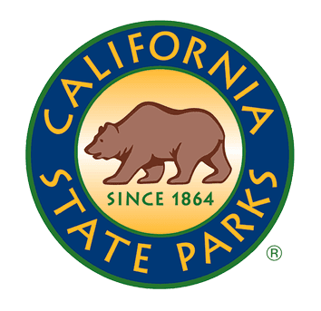

Wildfire Management Plan and
Local Operating Agreement

Topanga State Park

December 2024
Angeles District
California Department of Parks and Recreation

Topanga State Park
Wildfire Management Plan
and
Local Operating Agreement

_____________________________________________________
Richard Fink II
District Superintendent II, Angeles District
California Department of Parks and Recreation

_____________________________________________________
[Name]
Unit Chief, Los Angeles County Fire Department

_____________________________________________________
[Name]
Unit Chief, Los Angeles City Fire Department

TABLE OF CONTENTS

Topanga State Park 10
ANGELES DISTRICT EMERGENCY FIRE TELEPHONE DIRECTORY 10
FIRE EMERGENCY PROCEDURES 14
1. INTRODUCTION 17
1.1 PURPOSE OF THE PLAN 17
1.2 STATE PARK POLICY 18
1.2.1. Natural Resource Management Policy 18
1.2.2. Cultural Resource Management Policy 19
1.2.3 Museum Collections Management Policy 19
1.2.4 Facilities Management Policy 20
1.2.5 Public Safety Policy 20
1.3 FIRE MANAGEMENT OBJECTIVES - WILDFIRE PREPAREDNESS, RESPONSE, REPAIR, AND RECOVERY 20
1.4 PARK UNIT DESCRIPTION 21
1.4.1 Topography 22
1.4.2 Climate 23
1.4.3 Wildland Urban Interface (WUI) 23
1.4.4 Natural Resources 24
1.4.5 Cultural Resources 26
1.4.6. Facilities Resources 27
1.4.7 Public Safety Concerns 27
1.5 WILDFIRE POTENTIAL AND FIRE HISTORY 28
1.6 ROADS AND ACCESS 31
1.7 UTILITIES AND POWERLINE CLEARANCE 34
1.8 AVOIDANCE AREAS 35
1.8.1 Avoidance Areas – Cultural Resources 35
1.8.2 Avoidance Areas – Sensitive Natural Resources 36
1.8.2.1. Avoidance Areas – Aquatic Resources 37
1.9 WILDFIRE COMPARTMENTS 37
1.9.1 Compartment 1 [Garapito] 38
1.9.2. Compartment 2 [Trippet] 39
1.9.3 Compartment 3 [Lower Topanga] 41
1.9.4 Compartment 4 [Santa Ynez] 43
1.9.5 Compartment 5 [Temescal] 44
2. BEFORE THE FIRE: FIRE PREPAREDNESS 46
2.1 WILDFIRE PLANNING 46
2.1.1 Evacuation Routes 46
2.1.2. Community of Topanga Evacuation Plan 47
2.1.3. Collections Evacuation Plan 48
2.1.4. Quarterly Angeles District Emergency Preparedness Team Meetings 48
2.2 WILDFIRE PREPAREDNESS 48
2.2.1. Response Equipment and Resources 48
2.3 WILDFIRE PREVENTION MEASURES 50
2.4 FACILITY IGNITION PREVENTION PROGRAM (FIPP) 51
2.4.1. State Parks Buildings and Structures 51
2.5 WILDLAND URBAN INTERFACE (WUI) AND NON-STATE PARKS STRUCTURES 52
2.6 FUELS MANAGEMENT 53
3. DURING THE FIRE: FIRE RESPONSE 56
3.1 ORGANIZATION: ICS 56
3.2 STATE PARKS ROLES WITHIN ICS 56
3.2.1. State Parks Agency Representative or Unified Command 56
3.2.2. Resource Advisor (READ) / Fireline Resource Advisor (REAF) 57
3.2.3. State Parks Peace Officer (Ranger) 58
3.2.4. Damage Inspection Technical Specialist 59
3.2.5. Geographic Information Systems Specialist (GISS) 59
3.2.6. Field Observers (FOBS) 60
3.3 COMMON RESPONSIBILITIES OF ALL ICS PERSONNEL 60
3.3.1. Incident Command Post Safety and Attire 61
3.3.2. Documentation 61
3.3.3. Media 61
3.4 RESOURCES FOR DETECTING AND TRACKING WILDFIRES 62
3.5 WILDFIRES THREATENING A STATE PARK 62
3.6 WILDFIRES ON STATE PARKS LANDS 63
3.6.1 Initial Attack 64
3.6.2 Extended Attack 64
3.6.3. Large Fires - ICS Type 1 and Type 2 Organizations 65
3.6.4. Fire Safety and Qualifications 66
3.6.5 Modified Fire Suppression and Values at Risk 66
3.7 Invasive Species Mitigation During Fire Suppression 71
3.8 COMPARTMENTS AND COMPARTMENT MAPS 72
3.8.1 Compartment 1 [Garapito] 73
3.8.2 Compartment 2 [Trippet] 74
3.8.3 Compartment 3 [Lower Topanga] 75
3.8.4 Compartment 4 [Santa Ynez] 76
3.8.5 Compartment 5 [Temescal] 77
3.9 INCIDENT COMMAND POSTS (ICPs) AND FIRE CAMPS LOCATED ON STATE PARKS PROPERTY 78
3.10. SUPPRESSION REPAIR 78
3.10.1 Responsibility 78
3.10.2 Repair Phasing 79
3.10.2.1 Extended Repair 79
3.10.3 Repair Guidelines 80
4. AFTER THE FIRE: FIRE RECOVERY 84
4.1 POST-FIRE RESOURCE DAMAGE – FIRE RECOVERY 84
4.2. TREE HAZARDS 86
4.3 FEDERAL EMERGENCY MANAGEMENT AGENCY (FEMA) 86
4.4 WATERSHED EMERGENCY RESPONSE TEAM (WERT) 86
4.5 BURNED AREA EMERGENCY RESPONSE (BAER) 86
4.7 After Action Reviews 86
5. APPENDICIES 87
A. National Fire Danger Rating System 87
B. Red Flag Program 88
C. Glossary 89
D. Federal and State Endangered/Sensitive Species Acronyms 90
E. CAL FIRE/State Parks Interagency Agreement 90
F. Out-of-District Request Protocol 101
G. References 101

Topanga State Park

ANGELES DISTRICT EMERGENCY FIRE TELEPHONE DIRECTORY

CALIFORNIA STATE PARKS – ANGELES DISTRICT (call first and in this order)
Position Title | Current Staff | Phone Number
Routed through Local Police Department Dispatch System |  | 911
State Parks 24 Hour Emergency Dispatch |  | (951) 443-2969
District Superintendent | Richard Fink II | (424) 464-6792
Deputy District Superintendent | Lori Harrod | (310) 699-1724
Chief Ranger | Darrell Readyhoff | (310) 699-1727 cell
Public Safety Superintendent | Jeffrey Langley | (818) 963-0783 cell
Senior Environmental Scientist Supervisor | Noa Rishe (Acting) | (310) 699-3951 cell
Cultural Resources Program Supervisor | Barbara Tejada | (310) 699-1703 cell
Program Manager | Brian Hisel | (818) 880-0395 office
Park Maintenance Chief | Jeremy Harkless | (818) 880-0384 office
Topanga SP Supervising Ranger | David Gunn | (818) 403-1787
Malibu SP Supervising Ranger | Christy Araujo | (310) 699-1732 cell; (818) 880-0367 office
Malibu SP Supervising Ranger | Joseph Grier | (310) 699-1720 cell
Malibu SP Supervising Ranger | Josh Pace | (818) 403-0258 cell
Malibu SP Lifeguard Supervisor | John Regan | (310) 699-1734 cell
Los Angeles Supervising Ranger | Jonelle Mckie | (310) 699-1721 cell
Los Angeles Supervising Ranger | Scott Raley | (818) 403-8237 cell
Communications Analyst | Cassandra Chavez | (818) 821-4661
DISTRICT RESOURCE ADVISORS (READs)
Lead READ | Noa Rishe (Acting) | (310) 699-3951 cell
Lead READ | Barbara Tejada | (310) 699-1703 cell
READ – Cultural Resources | Ann Stansell | (818) 644-9699 cell; (818) 880-0377 office
READ – Natural Resources | Cody Hoffman, Environmental Scientist | (916) 823-2344 cell
READ – Natural Resources | John Ota, Environmental Scientist | (310) 945-8512 cell
READ – Natural Resources | Dayana Doroteo Senior Maintenance Aide | (818) 602-3780 cell
READ – Natural Resources | Megan Edic, Environmental Scientist | (818) 451-9642 cell
READ – Natural Resources | Carlos Calderon, Forestry Aide | (818) 441-9059 cell
READ – Natural Resources | Will Cruz, Forestry Aide | (818) 614-2485 cell
READ – Natural Resources | Michael Moss, Forestry Aide | (805) 490-1779 cell
READ – Natural Resources | Maegan Ealy, Forestry Aide | (805) 443-0144 cell

LOCAL FIRE AGENCY PRIMARY CONTACTS
Los Angeles County Fire Department | 911  Command Center (323) 881-6183  Division 7 Assistant Fire Chief (310) 317-1802  Fire Station 69 (310) 455-1766  Fire Station 89 Battalion Chief Headquarters (818) 596-2272
Los Angeles City Fire Department | 911  Emergency Dispatch (800) 577-5677  Fire Station 23 Palisades Highlands (310) 575-8523  Fire Station 84 Woodlands Hills (818) 756-8684

ASSISTANCE TO PERSONS
Ross Baker Towing (Topanga) | (818) 886-7411

LEESSES / EASEMENTS
Cholada Thai Restaurant | (310) 317-0025
The Malibu Feed Bin | (310) 456-2043
Reel Inn Malibu | (310) 456-8221
Wyle's Bait& Tackle | (310) 456-2321
Rosenthal Wine Bar & Patio | (310) 456-1392
Oasis Imports | (310) 456-9883
Camp Josepho | (310) 459-9093  Booking (818) 933-0130
Los Angeles Regional Interoperable Communications System | (323) 881-8291

RESOURCE MANAGEMENT
National Park Service – Santa Monica Mountains Recreation Area | (805) 370-2300 (general)  (661) 723-2703 (business)  (805) 370-2301 (closures)  Angeles Emergency Communications Center (USFS and NPS) (661) 723-3620
Michael Wilson, Fire Information Officer | (805) 370-2364 office
California Department of Fish and Wildlife  Southern California Fire Management Zone (TNR) | (619) 713-2201 (business)  (619) 557-5262 (after hours)
Mountains Recreation and Conservation Authority | (323) 221-9944 (business)  (310) 454-1395 (Temescal Gateway Park)
Santa Monica Mountains Conservancy | Dispatch (310) 456-7049

MEDICAL FACILITIES
Kaiser Permanente Woodland Hills Medical Center | 911 or  (833) 574-2273  5601 De Soto Ave, Woodland Hills, CA 91367
Providence Cedars-Sinai Tarzana Medical Center | 911 or  (818) 881-0800  18321 Clark St, Tarzana, CA 91356
University of California, Los Angeles Santa Monica Medical Center | 911 or  (310) 825-9111  1250 16th St, Santa Monica, CA 90404

UTILITIES, ROADS, AND OTHER
Southern California Edison | (800) 655-4555 (customer support)  (800) 611-1911 (reporting outage and voltage issues)
Los Angeles Dep. of Water and Power | (800) 342-5397 (customer support)
Southern California Gas Company | (800) 427-2000 (commercial customer support)  (877) 238-0092 (questions about gas odor)  811 (DigAlert)
LA County Dept. of Public Works | (800) 675-4357 (urgent requests)
Las Virgenes Municipal Water District | (818) 251-2100 (24-hour emergency service)
California Department of Transportation | District 7 – Los Angeles (213) 897-3656  Right of Way & Land Surveys (916) 654-5413
Los Angeles Regional Interoperable Communications System | (323) 881-8291

LAW ENFORCEMENT
Los Angeles City Police Department | 911 or  (877) 275-5273 (non-emergency police response)
Los Angeles County Sheriff | 911 or  Sheriff’s Information Bureau (213) 229-1700  Malibu/Lost Hills Station (818) 878-1808
California Highway Patrol | 911 or  (800) 835-5247 (immediate non-emergency)  323-906-3434 (public information line)  580 West Valley Office (818) 888-0980

FIRE EMERGENCY PROCEDURES

REPORT OF A DETECTED FIRE
The origin of the fire MUST be protected for fire Investigators. For protocols for how to protect the fire origin, please see PMS-412, Guide to Wildland Fire Origin and Cause of Determination.

It is very important to the fire investigation that State Park staff record information about the fire and the reporter/informant/witness (reporting party). If safe, encourage the reporting party to stay on site to answer additional questions. At minimum, take every effort to obtain the reporting party’s contact information. See forms State Parks 385, 385A, and 386 (APPENDIX H)

From a Park Visitor
• Obtain specific location and note the time.
• Obtain informant’s name, address, telephone number, and driver’s license.
From an Employee, Resident, etc.
• Obtain specific location and note the time.
• Obtain the reporting party’s name and place of employment, contact information,
and supervisor’s name.

DISPATCH
Contact 9-1-1 for an emergency. If the primary fire control organization is known, notify the appropriate agency, the Los Angeles City Fire Department for fires on city land and the Los Angeles County Fire Department for fires on county land (Topanga State Park Wildland Urban Interface Map for city and county boundaries)

Report the following SIZE UP information as is feasible considering safety concerns:

Location of Fire
- Be as specific as possible.
- Provide landmarks and cross-streets or roads.
- If you have GPS coordinates, indicate the mapping/coordinate units/system (i.e. decimals, degrees, minutes), and share the coordinates with dispatch.
- Ask the receiver to repeat the coordinates back to you for verification.
Size of Fire
- Estimate acreage.
- If you are unable to estimate acres, estimate the number of a known area/unit such as a football field(s).
Rate and Direction of Spread
- Estimate the rate of spread.
- Is the fire moving quickly or slowly? Try to use the same area and size estimate unit. Is it growing 1 football field/5 minutes, or 3 football fields /1 minute?
- Which way is the fire moving?
- Try to determine where the fire is headed.
Type of Fuel
- Is the fire burning in grass (light fuels), chaparral (medium to heavy), oak woodland, ponderosa pine forest (heavy fuels), or other applicable fuel type?
- Is the fire on the ground, in the shrub/tree canopy or both?
- Are structures involved?
- If so, how many?
Evaluate the Fire Potential
- This is also an important concern.
- Depending on your safety, take a moment to see if there are any problems, such as visitors in the area or threats to structures or resources.
- Electrical concerns are a priority. Are there power lines? Do not approach areas with live electrical.
Note Access Routes and Staging Areas
- Try to determine the best route to the fire for the responding resources.
- Do not block the way.
- If a good staging area has been identified in this plan, direct incoming resources to that location.
Hazards and Constraints
- Are there any known hazards such as downed powerlines, down trees, etc.
- Are there special considerations and constraints such as weight-limited bridges, threatened emergency repeaters?
Actions We Are Taking
- Are we evacuating campgrounds?
- Are we closing park roads?
- Are we notifying and dispatching State Park personnel?
- Include the quantity of people and equipment dispatched and on a standby basis.
- Do not hang up the telephone before the fire department dispatch has hung up. They may be transmitting information and will likely have follow up questions for you.
Follow-Up
- Make additional telephone calls to the responding agency dispatch immediately upon receiving new information about the wildfire and relevant to incoming resources such as reports of a powerline down, a significant change in fire behavior, trees blocking access, substantial wind shifts, etc.

DISTRICT NOTIFICATIONS
Take the following steps to notify State Park personnel:
- 9-1-1 first for an emergency
- Notify the District office starting with the first person and number listed in the Angeles District Emergency Telephone Directory and State Park Dispatch (SURCOM) of any fire that has started in or threatens the unit.
- District Superintendent will notify the Department Operations Center (DOC).
- Notify district State Park personnel by telephone or radio, if applicable, and follow the established procedures.
- Call all personnel as identified by priority on the Angeles District Emergency Telephone Directory. Personal phone numbers are listed in an internal telephone directory that all program heads have access to. READs should be notified at the start of a wildfire on park land to assist in sensitive resource protection.
- Notify all relevant lessees, neighboring property owners, residents, etc., as identified on the District Wildfire Telephone Directory.

- INTRODUCTION

1.1 PURPOSE OF THE PLAN

This document is the Wildfire Management Plan for Topanga State Park and serves as the Local Operating Agreement between California State Parks Angeles District and the local fire departments; Los Angeles County Fire Department (LACoFD), an agent of California Department of Forestry and Fire Protection (CAL FIRE), and Los Angeles City Fire Department (LAFD). Topanga State Park is owned and managed by California Department of Parks and Recreation (DPR). The park is 11,525 acres in size, most of which lies within the boundaries of the City of Los Angeles (Topanga State Park Wildland Urban Interface Map) Approximately 80% of the park is within the City of Los Angeles Fire Department Local Responsibility Area and 20% is within the County of Los Angeles Local Responsibility Area. Topanga State Park is a popular recreation area, within day use of over 12 million residents of Los Angeles and approximately 40% of its borders are considered wildland-urban interface (WUI) areas. The park consists of steep and rugged terrain dominated by chaparral and protects numerous natural and cultural resources. The intent of this Wildfire Management Plan is to provide a framework for 1) preventing unwanted wildfire events through fuel modification and planning, 2) guiding wildfire suppression techniques to safely protect human life and livelihood, park infrastructure, and sensitive resources during wildfire, 3) preserving unique landscapes and enhancing wildlife habitat through vegetation management and wildfire repair. Unless specified otherwise, State Parks prefers to let Topanga State Park burn in a wildfire event. Fires should be excluded from areas recently burned to prevent vegetation type conversion, and areas with sensitive resources to preserve the park’s natural and cultural significance. Where possible, backfiring from established fire roads to oncoming fire is the preferred fire suppression method. Fire control involves all aspects of elimination and containing unwanted fires including prevention, pre-suppression, suppression, and repair activities.

The approved Local Operating Agreement will remain in effect until significant revisions require re-approval. The circumstances which may precipitate the need to revise and re-sign this agreement, include: 1) acquisition of new DPR land, 2) change in policy, 3) change in land use adjacent to the park, 4) change in senior level staff, such as fire chiefs and district superintendents, and 5) a major wildfire event exposes shortcomings or changes management objectives in the current agreement.

The objectives for this plan include:

- Function as the local working agreement between California State Parks [Angeles District] and Los Angeles County Fire Department, an agent for the California Department of Forestry and Fire Control (CAL FIRE), and the City of Los Angeles Fire Department for all activities related to wildland fires in Topanga State Park.
- Identify communication protocols between State Parks and Los Angeles County Fire Department and the City of Los Angeles Fire Department.
- Identify roles and responsibility for all activities related to wildland fires – planning, response, and repair.
- Identify hazards, staging areas, access points, and potential control lines.
- Inform the Los Angeles County Fire Department and the City of Los Angeles Fire Department of DPR policies, sensitive park resources, and fire management objectives.
- Identify avoidance areas, and avoidance and minimization measures.
- Identify fire exclusion zones, including Trippet Ranch Cultural Preserve, slopes surrounding Topanga Creek, and chaparral vegetation burned within 30 years.
- Develop vegetation management objects for wildfire and forest resilience.
- Identify repair standards and constraints.
- Inform California State Park Department staff of functions within the Incident Command System with respect to wildland fire.

1.2 STATE PARK POLICY

1.2.1. Natural Resource Management Policy
The Departmental policies on Natural Resource Management are contained in the Department Operations Manual (DOM), Chapter 0300, Natural Resources. The Department’s goal is to prevent all unwanted human-caused fires. Given that unwanted fires will occur, it becomes the responsibility of the Department to minimize damage to park resources from the wildfire itself and from all suppression activities. Each unit of the State Park System that may experience wildland fires must have a Wildfire Management Plan. The DOM provides general natural resource wildfire management policy and fuel modification policy.

- DOM 0313.2 – Fire Management
“The Department’s goal is to prevent all unplanned human-caused fires on its lands. Given that some unplanned fires will occur, both lightning-caused and human-caused, it becomes the Department's responsibility to protect human life, and to minimize damage to park facilities and resources from wildfires and from all suppression activities.

Management actions for wildland fires on Department lands involve pre-fire planning, fuel (vegetation) management, public safety measures, fire control support, post-fire evaluation and rehabilitation.”

- DOM 0313.2.1.2.1 – Flammable Vegetation/Fuel Modification Policy

“It is the Department's policy to prohibit the construction and maintenance of firebreaks, fuelbreaks, and other fuel modification zones on Department lands, except when:

- Required by state law to clear around its structures/facilities;
- Previous legal commitments have been made to allow the creation and maintenance of fuel modification areas;
- It is critical to the protection of life or park resources; or
- Park vegetation 130 horizontal feet from a non-Department habitable structure is capable of generating sufficient radiant/convective heat when burning under Red Flag Warning conditions to ignite the habitable structure.
All identified and approved fuel modification zones will be described in the unit wildfire management plan and will be constructed and maintained to the Department’s standards (refer to Natural Resources Handbook). All proposed fuel modification projects must be reviewed for environmental impacts (see DOM Chapter 0600, Environmental Review). All other areas previously modified for fire protection purposes but not meeting the above exceptions will be returned to natural conditions.”

1.2.2. Cultural Resource Management Policy
The Departmental policies on Cultural Resource Management are contained in the Department Operations Manual (DOM), Chapter 0400, Cultural Resources. Wildland fire management plans will be developed in consultation with cultural resource specialists and include locations and characteristics of cultural resources. Cultural specialists shall be consulted to address prevention, detection, and suppression, including special procedures for fighting fire in historic structures, and museum collections. Fire trained Cultural specialists will be consulted during fire response and suppression repair activities. Cultural resources should be protected in areas of the fire incident from looting, vandalism, or erosion. The DOM provides general cultural resource wildfire management policy for archaeological resources and historic structures.

- DOM 0406.4.4 – Fire Management (Historic Structures)
- DOM 406.4.5 – Wildland Fires
- DOM 406.4.6 – Post-fire Evaluation
- DOM 406.4.7 – Emergency Management Planning Policy

1.2.3 Museum Collections Management Policy
The Departmental policies on Museum Collections Management are contained in the Department Operations Manual (DOM), Chapter 2000. Contingency plans for protecting and prioritization of museum objects during fire, flood, earthquake, or other crises shall be incorporated into the park’s Emergency Plan and prepared or reviewed by a Museum Curator and the Chief Ranger. The DOM provides general museum collection emergency plan guidance.

- DOM 2010.9.5 – Emergency Plan
“Contingency plans for protecting museum objects during fire, flood, earthquake or other crises shall be incorporated into the park’s Emergency Plan (see DOM Chapter 1800, Emergency Planning). The plan shall be prepared or reviewed by a Museum Curator and the Chief Ranger. The plan should take into account the following circumstances:

- The safety of staff and visitors always comes first.
- Trained staff, equipment, supplies, and transportation to assist with museum collections may be limited or unavailable.
- During an emergency, decisions may have to be made in haste about which objects will be moved, given additional protection, or left behind.
- It may be necessary to evacuate some or all museum objects to another location.
- A record is needed of objects moved and actions taken during the emergency.
- After the immediate crisis, there may be a need for temporary facilities elsewhere at the part or off-site.”

1.2.4 Facilities Management Policy
The Departmental policies on Facilities Management and FIPP protections are contained in the Department Operations Manual (DOM), 0800. Wildland fire management plans are developed in consultation with Facilities supervisors to outline structural hardening, defensible space, wildland fuels reduction and Facility Ignition Prevention Program (FIPP) protections.

1.2.5 Public Safety Policy
The Departmental policies on Public Safety are principally outlined in DOM 1300, Lexipol Law Enforcement Policy Manual. The State Park Peace Officers are responsible for closure of the fire area to the public, ensuring public safety, facilitating evacuation routes from campground and day use areas, evacuation of patrol vehicles and firearms, and enforcing closed areas curing response and recovery. The Departmental policies on emergency procedures are found in the DOM 1500, Emergence Management. In accordance with State law and regulation, the Department has adopted the procedures and processes of the Standardized Emergency Management System (SEMS) and the Incident Command System (ICS) as the Department's method of dealing with emergencies and disasters.

1.3 FIRE MANAGEMENT OBJECTIVES - WILDFIRE PREPAREDNESS, RESPONSE, REPAIR, AND RECOVERY
The goal of wildfire management for Topanga State Parks is to protect sensitive natural and cultural resources, support healthy and fire resilient ecosystems, reduce risk to public safety, and build effective communication between State Parks and response agencies. Wildfire management does not mean the elimination of wildfire potential in Topanga State Park. Wildfire is a natural process and an important ecological event that restores and balances natural ecosystems. Many areas in the park have not burned for 50+ years. Where possible and unless specified otherwise in the wildfire management plan, California State Parks prefers to allow wildfires to safely burn accumulated fuel loads while protecting the public and sensitive resources. Fire management objectives for this plan include:

- The district will take educational and operational measures to prevent, insofar as possible, human caused wildfire ignitions.
- Plan and implement operational measures that protect sensitive resources and create defensible space around park structures.
- Train and organize District personnel to act as Agency Representatives and Resource Advisors and other positions as identified by the Incident Management Team, with the approval of the District Superintendent or their designee, to any incident within the park unit.
- Identify appropriate modified suppression methods in specific areas within the unit that minimize resource damage.
- Establish fuel management objectives for the park.
- Identify modified fire suppression activities, avoidance, and mitigation measures for sensitive resource areas.
- Identify fire exclusion zones to protect sensitive natural and cultural resources.
- Identify measures for reducing the spread of invasive species.
- Identify opportunities where fuels can be consumed safely if it reduces future wildfire threats or benefits resources during the incident.
- Identify required repair standards.
- Identify appropriate recovery or mitigations after the fire.
- Identify all hazards to emergency responders within the park unit.
- Establish pre-determined safety zones, temporary refuge areas, and the opportunity for potential holding lines.
- Protect life first, and property and resources second.

The District Superintendent is responsible for all activities within the park unit. Qualified District Staff will be assigned to each incident as Agency Representative(s) and Resource Advisor(s). The District Superintendent may request assistance from State Parks Statewide Fire Management Resources, and other Departmental staff. The out-of-district assistance request protocol is attached in APPENDIX E.

1.4 PARK UNIT DESCRIPTION
Topanga State Park is one of the largest parks located in the Santa Monica Mountains National Recreation Area (SMMNRA). The park encompasses 11,525 acres extending from the Pacific Coast Highway to the hills above the San Fernando Valley. Most of this rugged, natural park lies within the urban limits of the City of Los Angeles and within day-use reach of some 12 million metropolitan-area residents. There are 2,565 park acres that fall outside of city limits and within Los Angeles County. Los Angeles County Fire Department and the City of Los Angeles Fire Department are the responding agencies in a wildfire event.

Many cultural resources are protected within Topanga State Park, including 60 recorded archaeological properties and a number of significant historical structures, sites, and landscapes. Several of these resources are maintained in the 158-acre Topanga Cultural Preserve and adjacent Trippet Ranch historic district, which includes the largest known Native American Village site within the park and is listed on the National Register of Historic Places, requiring the highest level of protection. Topanga State Park facilities include a maintenance yard and equipment, nature center, campground, day use facilities, lessees, residences, and offices.

Topanga State Park has twenty-six special status plant species and twenty-one special status animal species. These species are supported by the seven vegetation communities, with mixed chaparral being the dominate community, that make up the park. Despite the apparent destructiveness of wildfires, they play an important role in the natural process of the chaparral environment. The natural fire return interval for chaparral communities is 30-100 years, with too frequent fire causing type conversion from shrublands to grasslands. Wildfire is the dynamic natural force which renews the vegetative communities of the mountains. It is the park’s management objective to allow fire to play its natural and dynamic role in the evolution of the chaparral community to achieve various resource management objectives and to reduce hazardous accumulations of fuels. The majority of the park has not burned in over 50 years. To restore the natural fire frequency and chaparral habitats, Topanga State Park should be left to burn within reasonable public safety limits and outside of fire exclusion zones.

The unique topography of Topanga State Park and its close proximity to urban areas pose many challenges to wildfire mitigation and may hinder firefighter operations. There is limited access to large sections of the park as well as extremely steep and rugged terrain with the risk of erosion. The area is prone to extreme wildfire conditions when timing of ignition occurs during the hottest months and Santa Ana winds, and can be exacerbated by periods of drought. While a marine layer can form near the coast that may provide humidity and cooler temperatures during a wildfire, it can hinder visibility for Air Operations. Adjacent residential communities that border State Park boundaries are at risk during wildfire events, have high property values, and in some cases limited evacuation routes that can create commuter traffic and affect incident response into the park.

1.4.1 Topography
Topanga State Park is located in the Santa Monica Mountains, part of the Transverse Range geomorphic province. This is an east-west trending range, geologically complex and composed of a series of mountains separated by valleys that vary from narrow to somewhat broad. Within the park, geological formations are composed mainly of sedimentary strata with extensive intrusions of volcanic basalt. These mountains are extensively dissected by faults, with the Topanga Fault and the Santa Monica Fault being the major ones within the park. Elevations in the park range from 0 to 2,614 feet above mean sea level. Steep topography, unconsolidated soils, periodic heavy rainfall, and occasional earthquakes make this area naturally prone to floods, landslides, slope erosion, stream bank slumping, stream sedimentation, and log and debris jams. There are several geological features that provide critical habitat and draw visitors to the park, including Eagle Rock, Cathedral Rock, Temescal Peak, and Skull Rock.

Topography is the driving force of wildfires during routine fire risk days, usually from June to September. Fires that occur outside of high-risk days, September to December, are considered routine and rarely exceed 1000 acres. The steep slopes in Topanga State Park contribute significantly to wildfire behavior and firefighter safety.

1.4.2 Climate
The National Park Service considers Topanga State Park the best mainland example of the Mediterranean Biome, one of the smallest and most biologically diverse land types found on the face of the earth, with only 20 percent left undisturbed. The climate fluctuates with the seasons with hot, dry summers and mild, wet winters. Average annual precipitation is approximately 16 inches, which primarily falls as rain in the winter. Temperatures range from highs of 68º to over 100º F and lows from 38º to 58º F, depending on proximity to the coast. The frost-free period is from 300 to 350 days. On average, 86% of the rainfall occurs between November and March, with the majority (47%), concentrated in January and February from large storms that last for several days. The dry season is from May-October. Very little rainfall (1%) occurs in June, July, or August. Evaporation exceeds precipitation from April to November. During summer morning hours, a marine layer of fog is common along the coast and inland valleys, but by early afternoon, temperatures increase, and the fog dissipates. Every fall and winter foehn winds (strong and extremely dry downslope winds), called the Santa Ana winds in southern California, move through the region of the Santa Monica Mountains, increasing the risk of high intensity wildfires should ignition occur during this time. These hot, dry winds begin when masses of cold air form over the Great Basin and grow stronger as they spill south and west, down through the steep mountain canyons towards the ocean.

1.4.3 Wildland Urban Interface (WUI)
Approximately 8,960 acres of the 11,525-acre Topanga State Park is located within the City of Los Angeles, 30 miles from the heart of downtown. The remaining section of the park falls within the boundaries of the County of Los Angeles. The park is adjacent or in close proximity to the communities of Topanga, Pacific Palisades, Brentwood, Santa Monica and a number of communities of the San Fernando Valley, with the following major vehicular corridors all within easy access to the park: Topanga Canyon Boulevard (State Highway 27), Pacific Coast Highway (State Highway 1), San Diego Freeway (Interstate 405), Santa Monica Freeway (Interstate 10), and Ventura Freeway (U.S. Highway 101). An estimated 40% of Topanga State Park’s boundaries are within a Wildland Urban Interface (WUI), see Topanga State Park Wildland Urban Interface Map. An essential element to protecting human lives and property is creating defensible space around structures within the WUI. State Parks prioritizes projects that remove invasive flashy fuels from the landscapes, especially where residential areas border State Park land, and makes continuous efforts to educate the public on home hardening techniques.

1.4.4 Natural Resources
Topanga State Park contains seven identified vegetation communities. Most of the vegetation is dominated by mixed chaparral, but the park also supports coastal oak woodland, coastal sage scrub, annual grassland, chamise redshank chaparral, wetland, and a variety of riparian habitats (Appendix map). These habitats support a diverse wildlife community, with more than eighty mammal species, several hundred bird species, and over sixty reptiles and amphibians potentially occurring within the park.

There are twenty-six special status plant species, twenty-one special status wildlife species, and six rare natural communities found in the Santa Monica Mountains. Of these, eleven plant and nine wildlife species have been confirmed in Topanga State Park, although more species may be present but unaccounted for. There are two rare natural communities identified in Topanga State Park, Southern Sycamore Alder Riparian Woodland and California Walnut Woodland.

Table 1. SENSITIVE WILDLIFE SPECIES
Name | Status
Crotch bumble bee, Bombus crotchii | Candidate Endangered
Western pond turtle, Emys marmorata | Species of Special Concern
Coast horned lizard, Phrynosoma blainvillii | Species of Special Concern
Gertsch’s socalchemmis spider, Socalchemmis gertschi | State Critically Imperiled
Southern California steelhead, Oncorhynchus mykiss | Federally Endangered
tidewater goby, Eucyclogobius newberry | Federally Threatened
western mastiff bat, Eumops perotis californicus | Species of Special Concern
coastal whiptail, Aspidoscelis tigris stejnegeri | Species of Special Concern
California red-legged frog, Rana draytonii | Federally Threatened
Monarch, Danaus Plexippus plexippus | Candidate Endangered

Table 2. SENSITIVE PLANT SPECIES
Name | Status
Braunton’s milk-vetch, Astragalus brauntonii | Federally Endangered
Santa Monica dudleya, Dudleya cymosa ssp. Ovatifolia | Federally Threatened
White-veined monardella, Monardella hypoleuca ssp. Hypoleuca | State Rare
Sonoran Maiden Fern, Thelypteris puberula var. sonorensis | State Threatened
Spotted Humboldt’s Lily, Lilium humboldtii ssp. Ocellatum | State Rare
Western Ponysfoot, Dichondra occidentalis | State Rare
Plummer’s Baccharis, Baccharis plummerae ssp. Plummerae | State Rare
Santa Cruz Island Lacepod, Thysanocarpus conchuliferus | State Rare
California False Indigo, Amorpha Californica | State Rare
Fish’s milkwort, Polygala cornuta var. fishiae | State Rare
Globe’s Sedge, Carex globose | State Rare

Topanga Creek is one of three remaining waterways within the Santa Monica Mountains that provide critical passage to spawning and rearing habitat for steelhead. The Topanga Lagoon connects Topanga Creek and the Pacific Ocean, allowing steelhead passage upstream and downstream. During wildfire events, erosion, caused by a combination of removed or burned vegetation and heavy rainfall, spills sediment into waterways, increasing turbidity that can choke fish and blocks access to upstream estuaries. The mouth of the creek also supports a tidewater goby population that is at risk of being flushed into the ocean during large water and sediment flows. To maintain habitat for both species, it is State Park’s wish to keep the riparian corridor of Topanga Creek and the adjacent slopes from burning.

Fire is a natural process in southern California’s Mediterranean ecosystem with fire-tolerant or fire-dependent adaptations characteristic of many species in the ecosystem. Some of these communities, such as chaparral and coastal sage scrub rely on occasional fires as part of their regeneration process even though the short-term impacts of fire in these natural communities can appear to be severe. To promote the natural wildfire cycle, many chaparral species, such as redshank (Adenostoma sparsifolium) and chamise (Adenostoma fasciculatum), produce sticky resin that is flammable, also making them potential fire hazards. Indeed, most of the Santa Monica Mountains are considered a “Very High Fire Hazard Severity Zone” for the State Responsibility Area by the California Department of Forestry and Fire Suppression (CAL FIRE) based on the probability of an area burning and the expected fire behavior.

Vegetation plays an important role in the frequency and intensity of fires in the park and plant species and vegetation have evolved to survive repeated fires. The frequency is determined largely by ecosystem characteristics, weather, and timing of ignition sources while the intensity is influenced by the quantity of fuel available and the fuel’s combustion rates. Interactions between frequency and intensity are influenced by weather, topography, and fuel. The natural wildfire return interval, without human ignition, is 30-100 years. Human activity in and around the Santa Monica Mountains has reduced the length of fire-free intervals to between 10 and 30 years. This increased fire interval has encouraged the spread of invasive exotics that proliferate after both natural and human-caused disturbances, outcompeting native plants for valuable resources and contributing to increased fire frequency. Invasive grasses and forbs are flashy fuels that hold less moisture and create large monocultures that burn faster and hotter than natives. In the Santa Monica Mountains, species such as milk thistle (Silybum marianum), yellow star-thistle (Centaurea solstitialis), harding grass (Phalaris aquatica), and black mustard (Brassica nigra) dominate once native shrub and grasslands, encouraged by frequent wildfires, chaparral die back, and seed dispersal through human contact. During a wildfire event, heavy equipment, such as fire fighting vehicles, construction equipment and vehicles, and State Parks equipment can exacerbate the spread of exotic species. State Parks has taken repeated and aggressive measures to reduce invasives for wildfire resilience and to protect native resources, as described in sections below. To help reduce the spread of invasive species during a wildfire event, several measures can be taken as described in section 3.7 Invasive Species Mitigation During Fire Suppression.

1.4.5 Cultural Resources
Topanga State Park protects and preserves many different types of cultural resources, including historic landscapes, Native American sites and traditional lands of the Gabrielino/Tongva and Fernandeño Tataiviam people, Spanish and Mexican ranch sites, and 1900s homesteads and early recreational businesses. Many of these historically significant buildings and structures are located within the 18-acre Trippet Ranch Historic Zone, currently one of the main gateways into the park’s interior. The historic zone also contains natural and man-made landscape features and improvements associated with the 1940s historic operational core, Rancho Las Lomas Celestiales, (“Ranch of the Heavenly Hills”, a type of “gentleman’s ranch” found within the Santa Monica Mountains). Thirteen archaeological sites and numerous features and artifacts are also present within this historic zone and the adjacent Topanga Cultural Preserve. The Cultural Preserve is 158 acres and contains the National Register of Historic Places-listed Tank Site, the largest known archaeological site within the park and one of the oldest documented in the area. The southeastern edge of Topanga State Park borders Will Rogers Historic State Park, which contains an historic landscape and numerous buildings associated with the beloved entertainer, Will Rogers, as well as historic ranching features within the nearby Rustic Canyon. The southwestern edge of the park, along the Pacific Coast Highway is home to the Native American Village site of Topa’anga, the National Register-eligible historic Topanga Ranch Motel, and active leases that reflect the development of local recreational pursuits. Along the northern edge of the park runs the 7 to 8 miles of Dirt Mulholland road, the unpaved and unfinished section of the famous and paved portion of Mulholland Drive.

Fire protection for these areas is significantly different from other structures within the park. Archaeological sites are unique resources that once destroyed can never be replaced or duplicated, and the historical, scientific, and cultural data and meaning they represent is lost forever. It is of the utmost importance to protect these resources from inadvertent destruction by fire-related activities. Adding to the challenge for preservation, these sites and artifacts can be more or less invisible to the casual observer. While going unobserved in normal park operations is an advantage, they are prone to unintentional damage and destruction during fire suppression efforts and post-fire exposure. There are also areas of Topanga State Park that have not been surveyed for cultural resources. It is therefore important to have cultural Resource Advisors (READs) on site during a wildfire event to identify previously unknown, and known but unseen, resources that could be impacted by suppression activities.

1.4.6. Facilities Resources
Existing facilities within the park include fire and entrance roads, four parking areas, a campground, five residences, storage facilities such as machine and chemical sheds, barns, employee offices, restrooms, leases, interpretive facilities, and a visitor center. Majority of the critical park infrastructure are at or adjacent to Trippet Ranch, which includes three State Park staff residences (the historic Superintendent’s House adjacent to the parking lot and two residences 0.30 miles north accessed from Topanga Residence Road at the northeast corner of the parking lot), stable/barn used as ranger office space, machine shed used for park maintenance operations, storage yard, and the historic Skeet Lodge which houses a public nature center and exhibits. There is an additional residence at Musch Camp. Other critical infrastructures are Topanga Ranch Motel with 25 structures including a staff residence, and businesses in Lower Topanga. A major restoration effort is in the works for Lower Topanga that would include restoring native habitat and waterflow in Topanga Lagoon, as well as renovating current facilities and adding new structures and parking spaces. These details will need to be confirmed and included in future Wildfire Management Plan maps and information.

1.4.7 Public Safety Concerns
Park visitor, staff, and resident safety are top priority in a wildfire event in Topanga State Park. Residences and campsites within the park, particularly the primitive campground at Musch Camp, are considered high-risk areas and should be given special attention. Businesses located within the Lower Topanga area, including The Malibu Feed Bin, Cholada Thai Restaurant, Wyle’s Bait & Tackle, Rosenthal Wine Bar & Patio, Oasis Imports, and The Reel Inn, as well as parking lots with high visitor use, such as Trippet Ranch lot, Dead Horse lot, Los Leones lots, Lower Topanga lot, and Will Rogers parking lots, are also at risk. Camp Josepho Boy Scout Camp is located on private property adjacent to the park with the only escape route via Sullivan Canyon Fire Road in state park property and through the adjacent private and narrow neighborhood roads. Camp Josepho residents, staff, and visitors will need to be notified immediately of a wildfire threat due to the limited access to and from their property. The Topanga Lagoon restoration will affect what facilities, resources, and leases are at risk in this area during a wildfire.

In case of evacuation, the following routes are available from different areas of the park:

Musch Camp: A quarter mile long paved road leads to the Campground and the house above it, which connects to Hillside Drive. From there, visitors can reach Topanga Canyon. However, the road is narrow and difficult to navigate when other vehicles are present.

Trippet Ranch: The only way out to Topanga is via Entrada Road to Topanga Canyon Blvd (State Hwy 27). Although there are fire roads leading out of the area, Entrada may be the only safe way to exit the canyon during a fire. The Trippet Ranch Parking Lot is designated as a Public Safe Refuge in the Topanga Survival Guide for those who are unable to evacuate in time. The roads are narrow and could pose a challenge during mass evacuation.

Lower Topanga businesses: The Topanga Ranch Motel, lower Topanga residence, and other businesses in the area are adjacent to PCH and have easy access to the highway.

1.5 WILDFIRE POTENTIAL AND FIRE HISTORY
Wildfire behavior is predominantly influenced by a combination of fuels (vegetation or structures), weather (wind, temperature, humidity), and topography (slope, elevation, aspect). Together these factors can help or hinder the spread of wildfire. The Santa Monica Mountains are characterized as a Mediterranean climate with dry, hot summers and wet, cool winters. Most major wildfires (affecting more than 500 acres) in the park occur from September through December. The autumn months are especially prone to large wildfire events as they immediately follow 4 months of less than 1% rainfall that dries out the landscape. Temperatures can exceed 100 degrees and remain in the mid-nineties for several days at a time. During the autumn, Santa Ana winds push hot air from inland deserts towards the ocean and when coinciding with an ignition, can create extreme wildfire events. During Santa Ana conditions, wind velocities can reach 80 mph with extremely high temperatures, relative humidity can drop to 3%-15%, and vegetation and soil can experience a rapid loss of moisture. Much of the Santa Monica Mountains are considered a very high severity fire hazard zone by CAL FIRE based on fuel loading, slope, and fire weather.

In recent years, southern California has experienced a prolonged period of drought. This intensifies wildfire potential as vegetation is less resilient and has less moisture content, decreasing its fuel hour capacity. Drought is also a source of vegetation dieback that greatly enhances the rate of spread by ember-created spot fires in dead vegetation 1-3 miles ahead of the fire front during high winds. Relative humidity is also decreased in years of drought. On the other hand, years with high winter rainfall increase fire activity the following year likely because of flourishing exotic grasses that die back in the summer leaving a heavy fuel load.

Since the early 1900s, the California landscape has seen heavy wildfire suppression, however, this has not reduced frequent wildfire events in the southern region. Southern California has a unique fire regime influenced by vegetation type, drought, and annual extreme wind events, that together create dangerous conditions. When the timing of these conditions is paired with human-caused ignition, extreme wind-dominated fires are created. Unlike fuel-dominated fires, the amount of vegetation available to burn, while contributing, is not the limiting factor in the severity and spread of wind-dominated fires. Instead, extreme foehn wind events, rapidly spread fires through chaparral communities, that even when significantly reduced, are prone to ignition, and create many challenges to controlling wildfire events. A Santa Ana wind event in itself is not enough to cause a major wildfire event. Seventy percent of Santa Ana wind days have no fire events and only 5-6% of the Santa Ana wind events happen during an extreme fire. A bad fire event requires an ignition source. Human-caused ignitions account for 99% of all fires in north and south California coastal communities. Approximately 40% of Topanga State Parks’ borders are within WUI areas. As populations rapidly grow and wildland areas become more developed, the risk of ignition, number of people at risk, and losses of lives and property will increase. Records since 1919 when fire suppression efforts began in the Santa Monica Mountains show that nearly all wildfire starts were human caused, mostly by utility lines, arson, and vehicle collisions along access routes.

Since the 1920s thirty-seven wildfires have occurred within Topanga State Park property (Table 3), most of which were contained and put out quickly. The causes of most remain unknown. Many of the wildfires started outside park limits and spread into the park. Below are details of the largest and most destructive wildfires to pass through Topanga State Park and serve as examples of the conditions, fire behavior, and possible problem locations. Wildfires in surrounding areas that did not burn at least partially in Topanga State Park are not listed or discussed.

The largest fire to pass into the park, the Wright Fire of 1970, burned 28,202 acres total and was caused by burning trash in the Calabasas landfill, where embers spread to surrounding brush and the flames eventually made their way toward the ocean. This fire, combined with the Clampitt Fire that started the same day north in Newhall from downed powerlines in a Santa Ana wind event, combined to be one of Los Angeles’s deadliest wildfires in modern history. Together they scorched roughly 135,000 acres, destroyed over 150 homes, and claimed the lives of four civilians. Only 26 acres burned within Topanga State Park. Reported weather that day had daytime humidity below 10%, temperatures in the 90s, reaching 100F in some areas, and wind gusts up to 100 miles per hour. The chaparral was extremely dry due to many months with no rain.

Other notable fires over the years that spread into the park include Topanga Number 50 in 1938, Woodland Hills Number 65 in 1943, and Old Topanga Fire in 1993, each individually burned over 14,000 acres. The Topanga No. 50 fire was an accidental ignition caused by live coals dumped near brush at Trippet Ranch. A fire broke out and spread quickly, likely due to low humidity and high winds. The fire ignited November 23rd and was 100 percent contained November 30th, burning a total of 14,532 acres and destroying 33 structures. The Woodland Hills No. 65 fire, which ignited on November 6th, burned 14,919 acres, starting in Woodland Hills and pushed southwest by occasional Santa Ana winds to Point Dume. The cause of this fire remains unknown.

The Old Topanga Fire of 1993 is an example of the potential conditions and challenges for first responders during extreme wildfire events in Topanga State Park. While the cause of the fire remains unknown, on November 2nd, the day of ignition, a Red Flag Warning was issued by the County of Los Angeles Fire Department as Santa Ana winds and dropping humidity were predicted in the area. The fire quickly grew after inception with flame lengths reaching 200 feet and blowing embers that created spot fires as far as 2 miles ahead of the fire. Extreme wildfires such as this are significantly affected by changing winds and steep canyons, conditions not uncommon in Topanga State Park in November. Some neighboring communities had to be evacuated. Many roads within the community of Topanga are windy, narrow, and lead to the same egress points. Congested roadways caused delays for emergency vehicles through canyon access points. Home hardening techniques, which years later have become common practice, may not have been implemented and many homes were destroyed, possibly exacerbated by ornamental vegetation such as Cypress and Junipers that easily ignite and can spread flames to nearby houses. Water became a precious resource as tanks were depleted in the high demand. Without electricity to pump water to tanks and engines, crews had to wait for engines to shuttle water or water tender deliveries. As a majority, but not all of the park falls within LA city limits, LA City and County of Los Angeles resources were assigned to different sections of the fire, providing additional resources to support eithers efforts where necessary. Communication between the two agencies needed to be timely, constant, and consistent. By the time the fire was contained on November 11th, the fire burned 16,468 acres, claimed the lives of 3 civilians, and destroyed 388 structures.

The Palisades fire of 2021 is the only fire to start and remain within Topanga State Park. On May 14th, 2021 an arson caused brush fire spread through the rugged terrain, burning a total of 1,203 acres until completely contained on May 26th. Many of the old dozer lines created to contain the fire are currently being used as illegal biking and hiking trails and require annual repair to remove invasive species and cover with native brush.

Topanga State Park poses many constraints to wildfire suppression due to its size, topography, proximity to residential areas, and seasonal extreme weather such as foehn winds and hot autumn temperatures. The park has rocky and steep terrain with limited vehicle access on heavily vegetated slopes that are prone to roll out, erosion, and trap morning fog. During the right conditions, wildfires can be driven into canyons that create corridors where they rapidly spread and are difficult to contain. Radio communications may be hampered by steep canyon walls. WUI areas surrounding many of the borders create hazards for first responders, such as telephone wires and gas lines, puts public safety and their homes at risk, and creates road congestion at the limited park access points during evacuation. There are few fire hydrants in the park and water in neighboring communities may be limited or become inaccessible with power outages.

Table 3. TOPANGA STATE PARK FIRE HISTORY TABLE
Fire Name | Ignition Date  Alarm Date | Acreage Size (Total) | Acreage Size (in Park) | Cause of Fire
Topanga P.O. | 3/2/1925 | 172 | 98 | Unknown
Old Topanga NO. 2 | 9/12/1926 | 137 | 6 | Unknown
Cold Creek No. 35 | 9/7/1936 | 2,642 | 398 | Unknown
Topanga No. 50 | 11/23/1938 | 14,532 | 7,393 | live coals from residence
Las Flores No. 47 | 10/20/1942 | 5,841 | <1 (0.65) | Unknown
Woodland Hills No. 65 | 11/6/1943 | 14,919 | 168 | Unknown
Woodland Hills No. 47 | 8/29/1944 | 4,548 | 311 | Unknown
Topanga Fire No. 118 | 11/4/1948 | 3,278 | 1,496 | Unknown
Miller Fire No. 131 | 12/2/1948 | 41 | 41 | Unknown
Unknown | 8/28/1955 | 333 | 147 | Unknown
Unknown | 12/8/1956 | 46 | <1 (0.005) | Unknown
Unknown | 6/16/1957 | 411 | 151 | Unknown
Co. Fire 123158 (Canoga) | 12/31/1958 | 5,116 | 39 | Unknown
Unknown | 9/24/1958 | 107 | 3 | Unknown
Unknown | 10/15/1959 | 79 | 78 | Unknown
Unknown | 11/6/1961 | 7,847 | 4,994 | Unknown
Unknown | 9/8/1968 | 15 | 7 | Unknown
Wright Fire | 9/25/1970 | 28,202 | 26 | Embers from burning trash at Calabasas landfill
Unknown | 8/6/1972 | 85 | 52 | Unknown
Unknown | 2/2/1972 | 17 | 3 | Unknown
Trippet Fire | 10/30/1973 | 2,831 | 2,221 | Unknown
Canyon Fire | 11/14/1977 | 1,163 | 675 | Unknown
Mandeville Fire/LA City | 10/23/1978 | 6,086 | 2,224 | Unknown
Unknown | 11/16/1980 | 100 | 83 | Unknown
Unknown | 7/16/1984 | 7 | 7 | Unknown
Mulholland Fire | 7/30/1992 | 39 | 35 | Unknown
Old Topanga Fire | 11/2/1993 | 16,468 | 852 | Unknown
Topanga | 8/26/2008 | 1 | 1 | Vehicle fire into brush
Rustic | 9/15/2012 | 6 | 4 | Arson
Grand View | 4/27/2015 | <1 (0.09) | <1 (0.004) | Vehicle fire into brush
Topanga Cyn | 4/6/2015 | <1 (0.15) | <1 (0.15) | Vehicle
Topanga | 6/29/2017 | 20 | 20 | Unknown
Topanga 2 | 11/16/2019 | 4 | <1 (0.42) | Unknown
Palermo | 8/13/2019 | 2 | 1 | Unknown
Topanga | 9/8/2020 | 7 | 7 | Vehicle
Palisades | 5/14/2021 | 1,203 | 1,203 | Arson
Pacific | 6/08/2023 | <1 | <1 | Unknown
Fire History of Topanga State Park Calculated from The California Department of Forestry and Fire Protection’s Fire and Resource Assessment Program (FRAP). Wildfires in bold are fires of significance and are described in detail above.

1.6 ROADS AND ACCESS
The Los Angeles County Fire Department, one of the response agencies covering Topanga State Park, standard response time for rural areas is 12 minutes or less (LACFD 2021). There are 5 Fire Department Stations within several miles of the State Park, Los Angels County Fire Department Stations 23 and 69, and Los Angeles City Fire Department Stations 109, 19, and 69.

Trippet Ranch is the main entrance into Topanga State Park and has a parking lot and a staffed kiosk on weekends. From Trippet Ranch, visitors can hike 1 mile to Musch Campground, or do several day hikes. Trippet Ranch is accessed via Entrada Road, 1.2 miles from Topanga Canyon Blvd (State Hwy 27). Entrada Road is a narrow and windy two-lane road that goes through a residential neighborhood. There are many parked cars along the shoulder and hidden driveways. All roads in this neighborhood are dead ends. From the Ventura Fwy (Hwy 101) Trippet Ranch Parking Lot is 9.2 miles south via Topanga Canyon Blvd (CA-27) or 11 miles south via Old Topanga Canyon Rd. With normal traffic conditions, both routes can take anywhere from 20 to 35 minutes and are both windy and narrow with a limited shoulder and many parked vehicles in pull outs. From the Pacific Crest Highway (PCH), Trippet Ranch is about 5.9 miles north via Topanga Canyon Blvd and can take 14 to 25 minutes in normal traffic conditions. Here the canyon opens up as the road loses elevation down to the coast.

Los Leones, Dead Horse Trailhead, and Topanga Motel are the only other entrances into the park that have parking lots, however, these entrances are not regularly staffed. From Los Leones, visitors can hike to East Topanga Fire Road and then several miles to Trippet Ranch. The Los Leones trailhead is approximately 0.8 miles from PCH. Dead Horse Trailhead is located on Entrada Rd., 0.1 miles after turning off Topanga Canyon Blvd and 1.1 miles before Trippet Ranch parking Lot. This trailhead provides direct access to the Backbone Trail, which continues west into the backcountry for approximately 50 miles, and access to Trippet Ranch. The Topanga Motel entrance is right off the PCH and contains the defunct historic Topanga Ranch Motel and Cabins. This entrance is not well used and the cabins are unavailable to the public. Plans are underway to restore the lagoon and renovate the cabins and park entrance. Topanga State Park can also be accessed from Marvin Braude Mulholland Gateway Park, Temescal Gateway Park, and Will Rogers State Historic Park, which all have large parking lots. There are many other entrances into the park through residential neighborhoods. Popular trails with residential entrances are Santa Ynez Trail, Sullivan Ridge Trail, Musch Trail, Dirt Mulholland, Trailer Canyon Trail, Murphy Ranch Trail, and Backbone Trail. Many of these trails are or connect to fire roads that lead to back county areas.

Many unpaved dirt service and fire roads connect the park, mainly for operation and maintenance needs. Fire roads are used as evacuation routes, fire breaks, and emergency response routes. All fire roads are single lane, two-way roads and are maintained by California State Parks. Fire roads that lead into the park and their main entrance points are as follows: Fire Road Thirty, via Dirt Mulholland Dr. from top of Reseda Blvd (entered from Marvin Braude Mulholland Gateway Park); East Topanga Fire Rd, via Paseo Miramar from Sunset Blvd; Trailer Canyon Fire Rd, via Palisade Ct. from Palisades Drive; Cheney Fire Road via Penny Rd from Cheney Dr and Topanga Canyon Blvd; Sullivan Ridge Fire Road via Casale Rd from Capri Dr and Sunset Blvd; and Eagle Springs Fire Road and East Topanga Fire Road from Trippet Ranch. All fire road entrances have locked gates. Fire Road Thirty, Eagle Springs Fire Road, Eagle Rock Fire Road, and Temescal Ridge Trail via Trailer Canyon Fire Road, intersect at Hub Junction. Trippet Ranch to Hub Junction via Eagle Springs Fire road is 2.9 miles. Trailer Canyon Trailhead to hub Junction via Trailer Canyon Fire Road is 4.3 miles. Top of Reseda Blvd to Hub Junction via Fire Road Thirty is 2.6 miles. See the Topanga State Park, Park Road and Trail Map for full details of trail and vehicle access.

Camp Josepho, serving several programs of the Western Los Angeles County Council Boy Scouts of America, is situated between Rustic Ridge to the west and Sullivan Ridge to the east, just north of the southeastern boundary of the park. Camp Josepho has an ingress/egress through Sullivan Ridge Fire Road. The entrance to the Camp is accessed from Sunset Blvd. through the neighborhood of Riviera until reaching a locked gate signifying the start of State Park land and Sullivan Canyon Fire Road. The fire road is prone to erosion, rock fall, and is surrounded by natural landscape. The fire road is maintained and repaired annually, however, being the only egrees/ingress point, the Camp is at risk during wildfire evacuations.

Park roads mapped on the Fire Compartment Maps are subject to the following specifications and constraints:
- Existing Fire roads are kept at 12', with a maximum width reaching 20' in some instances. If needed turnouts can be created rather than widening the road, with DPR approval.
- No berms should be constructed, and no castings should be pushed into roadside vegetation. Soil piles accumulated during road maintenance and repair should be spread out within the road perimeter.
- To help direct vehicles, especially fire response vehicles driving in low visibility conditions, vegetation should be allowed to regrow or kept on the cliff side to act as berms.
- All sections of roads not significantly sloped (less than 20%) should be outsloped to 2%, permitting water to sheet off the road. Inside ditching and culverts should only be created if no other alternatives are viable.
- The recommended maximum road gradient shall be 12%, although gradients up to 15% for distances up to 25 feet are acceptable. If it can be clearly shown that there are no other feasible routes, short pitches of up to 20% may be permitted.
- Sections of road at and above 20% slope should have multiple water bars to direct water off the road at multiple points and keep water from running down the middle of the road (Road maintenance specifications according to DOM 1600, Facilities Maintenance).
- Where inside ditching and culverts are mandatory, culvert outlets must direct the outflow onto a natural energy dissipater, such as trees and rocks, to reduce the risk of erosion. Where no energy dissipater is available, one should be constructed using native materials.
- Culverts must be maintained regularly during the wet season.
- Trimming overhead and alongside roadways will be accomplished by hand, chainsaw or by grass type mowers. Correct pruning practices of woody vegetation shall be utilized. An ecological monitor must survey ahead of all pruning work during nesting bird season, February 15th through September 15th and in areas with sensitive species or habitat. An archaeological monitor must survey ahead of any road maintenance and repair taking place in cultural sites.
- No borrow pits or spoils areas should be developed without DPR approval.
- No turnarounds or alterations to existing roads should be constructed without DPR approval.
- No new roads or alterations to existing roads should be constructed without prior DPR approval.
- Use of roads within the park will be limited to official business only.
Where roads intersect areas identified as archeological sites, cultural sites, or sensitive plant or animal sites, no machine grading or widening of the roadbed will be allowed. All road maintenance at these locations will be done by hand and with a monitor.

1.7 UTILITIES AND POWERLINE CLEARANCE
Numerous powerlines of various utility companies traverse State Park System lands. Right-of-way agreements between the State and these companies contain permission for these companies to enter Department lands to maintain their lines. A substantial part of powerline maintenance involves trimming of trees for proper line clearance and clearance of vegetation from the area around the bases of power poles and towers. Utility companies’ representatives for their contractors are required to notify park staff before conducting line maintenance operations on park property. The basic legal requirements are found in Public Resources Code Sections 4292-4296. Powerlines in Topanga State Park are owned and cleared by Southern California Edison (SCE) and Los Angeles Department of Power and Water (LADWP). SCE power poles are cleared 10 feet around the bottom 8 feet of the pole.

Table 4. LINE CLEARANCE MINIMUM STANDARDS
Line Voltage | Minimum Clearance*
= 750 volts | None
≥ 2,400 volts, but < 72,000 volts | 4 feet
≥ 72,000 volts, but < 110,000 volts | 6 feet
≥ 110,000 volts | 10 feet
Clearances must allow for line movement due to wind and line expansion.

The majority of the park’s water supply is via connection to local water district supply lines, while most of the wastewater treatment within the park is handled via septic and leach field systems. For example, facilities at Trippet Ranch and the Lower Topanga Canyon area are connected to a local water line and sewage is treated via septic/leach systems, while the limited facilities at Los Leones are tied into municipal water and sewer systems. The closest municipal sewer line to the Lower Topanga Canyon area is about one mile south along Pacific Coast Highway, near Coastline Drive. Utility easements, including road, sewer, and water easements run throughout the park, with many such easements located near the Mulholland Corridor, and the Lower Topanga Canyon and Rustic Canyon areas.

Added and renovated infrastructure at Lower Topanga surrounding Topanga lagoon will require additional utilities. Information will need to be updated as the restoration project progresses.

1.8 AVOIDANCE AREAS
Avoidance Areas includes all sensitive Natural and Cultural Resources. They have been grouped together and buffered to 100-1000 ft. on the Topanga State Park Avoidance Map, in order to protect the exact physical location of the sites.

Avoidance Areas where no heavy equipment, vehicles, and retardant are allowed are grouped together and are shaded red on the attached maps. Avoidance Area maps will be provided to the IC as physical and digital copies. Physical copies must be tracked and collected at the end of the incident and before IC personnel leave.

Careful planning during wildfire response can help prevent damage to Avoidance Areas. State Parks is committed to using interagency planning efforts to prevent damage to Avoidance Areas during wildfire response. Fire Suppression activities may not occur within these areas without consultation of an Agency Representative, or a Resource Advisor assigned to the incident.

GIS shapefiles of avoidance areas are available for quick uploading into ArcGIS for the responding fire department to use. The shapefiles can be obtained by contacting the Senior Environmental Scientist, Supervising Ranger, Park Office, or the District Office, Agency Representative, or Lead Resource Advisor assigned to the incident.

1.8.1 Avoidance Areas – Cultural Resources
Cultural resources include archaeological and historical locations, features, structures, and landscapes. The locations of these resources are protected by law (Government Code § 6254.10 and PRC § 5097), thus the locations of the sites should not be relayed to the public or unauthorized individuals nor can any maps labeling these areas as “culturally sensitive” be generically released. Departmental Notice 2021-09 and/or DOM 0408.4.2 defines parks’ policies on confidential cultural resources data governance and includes all regulations that discuss cultural resources and public disclosure. It is stressed that these locations be referred to as “Avoidance Areas” during briefings without the indication of their cultural value. A Cultural Resource Advisor and Tribal Liaison must be consulted during wildfire planning and response.

Scientific evidence, such as radiocarbon dating, shows that people have been living in southern California for more than 9,000 years, with some evidence from the Channel Islands pushing the date back to at least 13,000 years ago. Archaeologists first documented and excavated these sites in the late 1940s identifying an early, distinctive cultural division they called the Topanga Complex, where sites from these earlier periods tend to have large numbers of stone milling and processing tools. The park is largely within Gabrielino/Tongva territory and Fernandeño Tataviam lands to the north, with influences from the Ventureño Chumash territory to the west. Cultural resources from these periods include burial and village sites, stone tool quarries, bedrock processing stations, hunting blinds and rockshelters, and shell midden deposits.

Topanga State Park’s historical land use reflects over 250 years of written history from the early days of Spanish terrestrial exploration, through various attempts by Spanish, Mexican, and Anglo-American settlers to eke a living out of the area’s coastal and mountainous regions. Historical resources from these periods include a lime kiln, quarry, refuse dumps, cabin and building sites, earthen dams, as well as old roads and trails.

Topanga State Park contains large areas not previously surveyed for cultural resources due to years of thick brush cover and steep topography. Areas not marked as Avoidance Areas are not necessarily free of cultural resources, as artifacts may be present but currently unknown. Additionally, many historical and archaeological remains are impossible to recognize, except by persons possessing specific knowledge and training in the applicable field. To emphasize recognition and protection of important cultural values wherever they occur, special measures must be taken.

1.8.2 Avoidance Areas – Sensitive Natural Resources
Sensitive natural resources include state and/or federally listed, plant and animal species and their habitats, sensitive plant communities, and species or populations that are locally endemic or significant and require special consideration. This classification includes old growth and heritage trees. A Natural Resource Advisor must be consulted during wildfire suppression planning and response.

Topanga State Park serves as some of the few habitats left for several endangered animal and plant species. Southern steelhead trout, tidewater goby, and red legged frog are federally protected species that are found at the outlet of Topanga Creek into Topanga Lagoon. Coast horned lizard is a California Species of Special Concern and found in many areas around the park, especially along fire roads and trails. It is essential to maintain their habitats both with preventative measures and during wildfire events. Sensitive plant species are found mainly in the southern half of the park. Species are clumped in small patches where viable habitat still remains. Santa Monica dudleya, Braunton’s milk-vetch, Plummer’s Baccharis, Santa Cruz Island Lacepod, Western Ponysfoot, California False Indigo, Spotted Humboldt’s Lily, Fish’s milkwort, Sonoran Maiden Fern, and Globe’s sedge are the sensitive plant species protected in the park. The biggest threat to these species is poaching and trampling from park visitors, development of habitat, and competition for space and resources from invasive species. During a wildfire, suppression techniques can eliminate entire local populations, especially as many species are hard to identify. Heavy equipment can spread invasives, already prevalent within the park, to healthy native habitats where invasives thrive in disturbed areas left behind from equipment. Invasives reduce the soil moisture content choking out natives and creating large infestations, reducing diverse habitats to monocultures that support fewer animal species. Once invasives become established on a landscape, they are a long-term problem that requires years, decades in worst case scenarios, of time, treatment, and funding. To protect native habitats, invasive species zones that require extra precautions or should be avoided, when possible, are outlined on MAP X around known invasive species infestations. Weed wash stations for invasive decontamination should be implemented wherever possible to reduce the spread of nonnative plants in the park.

1.8.2.1. Avoidance Areas – Aquatic Resources
Main waterways provide key habitat and corridors for numerous aquatic species, including federally and state listed endangered and sensitive species, such as California red-legged frogs (Rana draytonii), tidewater goby (Eucyclogobius newberryi), and southern steelhead trout (Oncorhynchus mykiss). Aquatic resources include streams, creeks, lagoons, wetlands, ponds, and riparian habitats. Many of these resources are rare habitats and contain rare plants and animals that are easily impacted by wildfire suppression techniques. Most of the streams and creeks within Topanga State Park are important aquatic resources. The main streams are Santa Ynez Canyon, Topanga Creek, Trailer Canyon stream, Garapito Creek, Caballero Creek, Santa Maria Creek, Parker Canyon stream, Pulga Canyon stream, Temescal Canyon stream, Rustic Canyon stream, and many of the connecting offshoots. Topanga Lagoon ending in Topanga State Beach is a saltwater marsh that connects ocean habitats with freshwater habitats of Topanga Creek and is equally important. Topanga Creek is one of the few endangered steelhead and tidewater goby habitats left in Southern California.

The most serious threats to aquatic species occur during wildfire suppression and as a result of wildfire. Fire retardant, dropped ahead of flames, contain toxic chemicals that can kill and harm aquatic species. These chemicals persist in the waterways until washed downstream. Heavy equipment and vehicles used for fire suppression that cross through creeks can kill aquatic species and alter the streambed and banks. After a wildfire, burnt slopes with reduced vegetation are at risk of erosion. Sediment carried off burnt slopes during heavy rains cause turbidity or increased sediment in waterways that can displace and choke species. Erosion can quickly damage the majority of habitats that aquatic communities depend on and can take years to recover, at which time endangered populations may plumet to concerning levels. Topanga Creek and the adjacent slopes are not only an avoidance area for fire suppression techniques but is also a priority for protection from burning.

Aquatic resources are protected by the Clean Water Act. Aerial retardant drops from aircraft are not allowed within 300 feet of water bodies. Retardant application from helicopters and engines are not allowed withing 100 feet of waterbodies. No digging or removing soil in streams is allowed. Pumping water from streams is only permitted when all other water sources are exhausted and with READ guidance who can recommend least impact options.

1.9 WILDFIRE COMPARTMENTS
Topanga State Park is divided into five wildfire compartments based on sensitive resources, topography, vegetation type and habitat resilience, and ease of access to guide incident operations in containing wildfires, prioritizing safety, and protecting resources in the park. The boundaries of the wildfire compartments are meant to be defensible in a wildfire during normal weather conditions. It is not the intent of this plan to conduct fuel modification along compartment boundaries. Existing roads, trails, and streams within the State Park should be used as defensible line against a wildfire or for backfiring. Frequently, the control methods, such as bulldozed lines, are more harmful to State Parks’ resource values than the fire itself and therefore, severe control techniques, such as dozer lines and retardant, should be avoided or reduced within the State Park. Preferred techniques for Topanga State Park include modified suppression options (refer to Section 3.6.5) and allowing the park to burn where possible. Fire roads should be used as control lines for backfiring towards the main wildfire over creating handlines and accompanying dozer lines around the fire perimeter, where feasible. Map X shows the wildfire compartments for Topanga State Park. Whenever possible, motorized vehicles will remain on established fire roads and will not enter vegetation. Motorized vehicles will also avoid activity around avoidance areas. Developed features on the maps that require protection are designated by their feature type (residences, visitor center, mission, etc.). Environmentally and culturally sensitive areas are designated as shaded red “avoidance areas.”

The State Parks Resource Adviser (READ) at the Incident Command Post can inform the Incident Commander of the Department’s desire to use modified suppression on its lands. The READ should supply the unit fire management compartment maps to the Planning Section Chief so that this objective can be incorporated into the Incident Action Plan.

1.9.1 Compartment 1 [Garapito]
Compartment Description
Compartment 1 is the northernmost edge of Topanga State Park. The southern boundary of the compartment runs west along Eagle Rock Fire Road until intersecting Cheney Fire Road and then runs along Cheney to the western edge. The compartment includes two androids, or areas separated from but within 2 miles driving distance to the main body of the park. This compartment serves as the northern gateway into the park and a crucial buffer and transition between the park and the highly urbanized San Fernando Valley. Adjacent land is owned and managed by the Los Angeles County Sanitation District Open Space to the East, the City of Los Angeles and Mountains Recreation and Conservation Authority to the North, and Los Angeles County to the West.

Compartment 1, including the adjacent androids, is dominated by mixed chaparral with areas of coastal sage scrub, coastal oak woodland, and chamise redshank chaparral along the northern edge. There are several riparian corridors that run through the compartment where bulldozing and retardant drops are prohibited. Most of compartment 1 is comprised of steep ridges and valleys, with the highest points in the northeast corner along Dirt Mulholland and on the northern side of Hub Junction.

Compartment 1 is a popular hiking and biking area with the majority of public access through Marvin Braude Mulholland Gateway Park, just outside of State Park land. There are no facilities or water sources within compartment 1. State Parks would like to let this compartment burn to reduce a 50+ year old fuel bed, restore natural fire frequency, and protect natural resources, as can be safely managed while protecting neighboring communities and other compartment cultural resources.

Access
Dirt Mulholland (Mulholland Dr.) runs horizontally through the uppermost portion of the compartment and serves as a fire road and multi-use trail. The dirt section of Mulholland Dr. begins just west of Encino Hills Drive and ends just east of Topanga Canyon Boulevard. Reseda Blvd connects directly to Dirt Mulholland, providing an easy entrance point to the main body of Compartment 1. There are two gates that require padlock keys for vehicle entrance. One gate is located at the top of Reseda Blvd where Marvin Braude Mulholland Gateway Park ends and Topanga State Park begins. The other is located at the northeast tip where Farmers Ridge Trail begins off Dirt Mulholland. Cheney Fire Road can be accessed via neighborhood roads off Topanga Canyon Blvd. Vehicles are not advised on Cheney Fire Road, which leads to Eagle Rock Fire Rd. Within the compartment Fire Road Thirty runs south from Dirt Mulholland along the eastern edge, leading to Hub Junction that intersects several fire roads for access into compartment 2, 4, and 5. All fire roads are single lane, two-way dirt roads. Additionally, Garapito Trail runs south through the middle of compartment 1 providing access by foot. The androids of compartment 1 are both connected to Mulholland Dr. with access into the park either by powerline road or multiuse trails.

Special Considerations
Cultural Resources
Compartment 1 contains a lime kiln site at the very northern edge of the park boundary in a drainage east of the entrance to Fire Road Thirty. This area should be avoided during suppression and kept from burning. It is recommended to have a plan for periodic brush removal directly around the feature to reduce the burn intensity that could cause damage.

1.9.2. Compartment 2 [Trippet]
Compartment Description
Compartment 2 is located on the western edge of Topanga State Park with most of the compartment consisting of an extending arm outstretched west towards Malibu. There is one android, or separate parcel of Topanga State Park that is not connected to the main part of the park, in compartment 2 that includes Hondo Road and is approximately 0.1 miles from the main body of the park. The northeast point of the compartment ends at Hub Junction where it intersects with Compartment 1, 4, and 5. The north boundary runs east along Cheney Fire Road and then follows Eagle Rock Fire Road to Hub Junction. The southern border starts at Hub Junction and runs west along Eagle Springs Fire Road. Eagle Springs Fire Rd. meets with East Topanga Fire Road which begins at the Trippet Ranch parking lot. The southern border follows this path but continues onto Waveview Drive and then buffers the Backbone Trail as it heads west towards Malibu.

This compartment contains most of the State Park’s cultural resources, including a cultural preserve, historic zone, and several avoidance areas. The Compartment also includes paleontological resources, most prominently along the Fossil Ridge Trail at the far western end of the park. The vegetation is a mix of annual grassland, coastal oak woodland, chamise redshank chaparral, and mixed chaparral with some areas of coastal sage scrub and riparian. The highest section of the park is at the most western tip, west of Old Topanga Canyon Rd. Here ridges reach up to 2500 feet. There is one walk in campground and four residences. The compartment is a popular hiking, biking, and horse biking riding area with the Backbone Trail running the entire length. There are two parking lots, Trippet Ranch and Dead Horse Trailhead that see daily visitors for recreation. The community of Topanga surrounds compartment 2 and is highly active in the ongoings of the park.

Access
The main entrance is at Trippet Ranch via Entrada Road off Topanga Canyon Blvd (State Hwy 27). Entrada Road winds through a neighborhood and leads to two parking lots, Dead Horse Trailhead, and the main entrance at Trippet Ranch. From Trippet Ranch, Topanga Residence Rd. connects the parking lot with two residences and is a paved road that dead ends 0.30 miles in at the residences. Musch Camp Service Rd. is a paved road that dead ends at a residence and the Musch Campground. Musch Camp Service Rd. connects to Topanga Canyon Blvd via Hillside Dr.

From Trippet Ranch, fire roads can be used for access to the interior of the park. Eagle Springs Fire Road runs northeast from Trippet Ranch to Hub Junction. East Topanga Fire Road runs south of Trippet Ranch and follows a ridgeline into compartment 4 where it ends at the park boundary in Parker Canyon. Several smaller public roads, Old Topanga Canyon Road, Henry Ridge Rd, Greenleaf Canyon Rd, Saddle Peak Rd, Schueren Rd, and Prier Rd, cross through compartment 2 and provide access to trails, the most prominent trail being the Backbone Trail that runs west to east through most of the compartment. Musch Trail begins at Trippet Ranch parking lot and heads northeast where it meets up with Eagle Rock Fire Road and Eagle Springs Fire Road.

Special Considerations
Public Safety
Most of compartment 2 borders WUIs. Neighborhoods of Topanga surround the park, and in some cases, are right up against the border so that a fence is the only barrier between wilderness and private land. During a wildfire, narrow and windy neighborhood roads become the evacuation route for park visitors and park residents, as well as the main route for first responders to the fire. Roads may become congested. Fire fighters should expect the possibility of a slow arrival to the scene.
Cultural Resources
Compartment 2 protects most of Topanga State Parks cultural resources. An 18-acre Historic Zone surrounds the historic Trippet Ranch and corresponding facilities. Many of the structures are historical and require special protection to keep from burning. A 158-acre Cultural Preserve adds heightened protection for a large Native American Village site and contains numerous avoidance areas that require special protection and limited fire suppression activities. Several early homestead features are also found along Hondo Canyon Trail. Historic and Native American resources are also located near portions of Eagle Springs and Eagle Rock fire roads, and fire operations should be limited to the defined roadbed width in those areas.
Natural Resources
There are many streams throughout compartment 2 that are no zones for retardant drops. Along some of these streams are sensitive plant and wildlife species that should be avoided during fire suppression.

1.9.3 Compartment 3 [Lower Topanga]
Compartment Description
Compartment 3 is classified as a separate unit due to the unique natural resources it contains. Majority of the compartment is a fire exclusion zone that should be protected from burning and where retardant drops are not allowed. The northern border runs east from the edge of the park along Waveview Dr. until hitting East Topanga Fire Road. The east compartment border follows East Topanga Fire Road south where it ends at a residential neighborhood and trail head at the end of Paseo Miramar Road. East Topanga Fire Road sits between the eastern edge of Compartment 3 and the western edge of Compartment 4. The western border of the compartment follows the boundary of the park. Tuna Canyon Dejoria Open Space is adjacent to the park on the west side. The southern edge meets the Pacific Coast Highway and contains several small businesses, and the historic Topanga Ranch Motel. There is one day use parking lot in compartment 3, Los Liones. Hikers can access East Topanga Fire Road from this parking lot.

Mixed chaparral is the dominant vegetation type that makes up the compartment. A small percentage of the landscape is coastal sage scrub, coastal oak woodland, chamise redshank chaparral, riparian, and fresh emergent wetland. Topanga Canyon Blvd (Hwy 27) runs adjacent to Topanga Creek, crossing it multiple times before the creek flows under PCH into the ocean. Topanga Creek not only is a riparian habitat that requires protection from retardant drops, but is also critical spawning habitat for endangered steelhead trout that are at risk of erosion after a wildfire. Together with the sensitive cultural and natural resources, it is important to keep compartment 3 from burning.

Restoration plans for Topanga Lagoon are underway, with the designing phase anticipated for 2024-2026 and construction 2027. The restoration will affect businesses currently leased on State Park land, the Topanga Motel Parking Lot, the Topanga Ranch Motel and Cabins, staff residence, and utilities. Infrastructure is likely to change and when the project is complete there will be additional visitor access and onsite State Park employees. Hazards, public safety, natural and cultural resources, and critical structure information will need to be updated on maps and documents as the project progresses.

Access
There is recreational access into the park along East Topanga Fire Road at Los Liones Parking Lot and Trippet Ranch Parking Lot. Lower Topanga offers limited access where three roads, Old Malibu Rd, Topanga Canyon Ln, and Rodeo Grounds Ln, enter the compartment but dead end within half a mile.

Special Considerations
Public Safety
The community of Topanga borders Topanga Canyon Road (Hwy 27), with many residences next to the park boundary. Topanga communities have essentially one evacuation route along Hwy 27 that leads south to the PCH. Both state highways are two lane roads that are frequently used by community members, commuters, and tourists that could become congested causing panic and slow access for first responders.
Facility Resources
There are two public restrooms and three parking lots at Los Leones along the southern edge. These are low priority for protection but may serve as refuge areas. There are several leases with small businesses on State Park land that are at risk of wildfire and require protection.
Cultural Resources
The historic Topanga Ranch Motel, located near the mouth of Topanga Creek is a small complex of 25 wooden cabins that have been out of use since State Parks purchased the land in 2001, with the exception of two units converted to an employee residence. These historical structures are a top priority to keep from burning or being damaged from wildfire. There are also Native American resources within the Trippet Ranch area and in the Cultural Preserve, that require special suppression techniques and an Archeologist monitor or READ during a fire. Additional resources are found in areas around Parker Mesa Overlook, off of East Topanga Fire Road.
Natural Resources
There are several endangered animal and plant species within compartment 3, including Santa Monica Dudleya, Astragalus brauntonii, Plummer’s baccharis, tidewater goby, and Southern steelhead trout. Topanga Creek is one of few freshwater habitats left for endangered southern steelhead and endangered tidewater goby. After a wildfire event and during the following rainy season, burned and exposed slopes are at risk of erosion, creating landslides that can displace and choke out endangered species by causing sediment in the creek. To protect these important resources, State Parks considers Topanga Creek a fire exclusion zone and efforts should be made to keep fire from the compartment.

1.9.4 Compartment 4 [Santa Ynez]
Compartment Description
The northern edge of Compartment 4 runs west along Eagle Springs Fire Road from hub junction, until reaching East Topanga Fire Road. The western edge of the compartment follows East Topanga Fire Road south until ending at the Paseo Miramar trailhead. The southern edge of the park runs up against the neighborhoods of Castellammare and Palisades Highlands, most of which are WUI areas. The eastern edge follows Temescal Ridge Trail from Hub Junction but ends approximately 0.6 mile after Trailer Canyon Fire Road.

Mixed chaparral dominates the landscape, with areas of coastal sage scrub, coastal oak woodland, chamise redshank chaparral, riparian, and annual grassland. Retardant drops are forbidden in riparian zones and the adjacent Santa Ynez Reservoir. There are several sensitive species and cultural resources in the compartment that are marked as avoidance zones for fire suppression.

Access
Recreational access into the park is from the Trippet Ranch Parking lot, and neighborhood access along Santa Ynez Canyon Trail, Wire Break Trail, Trailer Canyon Fire Road, and Temescal Ridge Trail. East Topanga Fire Road can be accessed from Trippet Ranch Parking lot in compartment 2 and from Paseo Miramar Road on the southern end of Compartment 4. Trailer Canyon Fire Road has two gates, as it starts outside of the park at the end of Palisades Ct. There are two gates along Temescal Ridge Trail about 2 miles south of Hub Junction. Trailer Canyon Fire Road leads to Temescal Ridge Fire Road which intersects compartments 4 and 5. Temescal Ridge Fire Road leads to Hub Junction and access to compartments 1 and 2.

Special Considerations
Public Safety
The neighborhoods of Castellammare, and Palisades Highlands along the southern border are WUI areas and are at significant risk during a wildfire event.
Due to the large size of the compartment and remoteness of the land, many day users could be miles away from their vehicle at the onset of a wildfire in Topanga State Park.
Cultural Resources
There are two main areas where cultural resources are known to be present in the compartment, including Native American resources adjacent to Trippet Ranch, and both historic and Native American resources along Santa Ynez Canyon.
Natural Resources
There are several endangered plant species in the compartment, the most prominent being Dudleya cymose ssp. Ovatifolia and Astragalus brauntonii. While wildfire poses a threat, suppression techniques especially with heavy equipment are the main concern and need to be avoided in these areas.

1.9.5 Compartment 5 [Temescal]
Compartment Description
Compartment 5 is the largest compartment at approximately 3,542 acres. The Northwest corner meets compartments 1, 2 and 4 at hub junction. The northern edge runs up against LA County Sanitation District Open Space, where the landscape remains the same and is undeveloped. The western edge of the park follows Temescal Ridge Trail before veering west towards Santa Ynez Canyon and bordering the neighborhoods of Palisades Highlands. The southern edge of compartment 5 borders the neighborhoods of Pacific Palisades and Riviera, Temescal Gateway Park, Rivas Canyon Park, and Will Rogers State Historic Park.
The eastern edge runs along Rustic Canyon for about 2.5 miles and then runs along Sullivan Ridge Fire Road in Sullivan Canyon, the next canyon eastward, and ending along the neighborhoods of Riviera. In between Rustic Canyon and Sullivan Canyon and within park boundaries sits Rustic Canyon Park, a 44-acre park owned and managed by the City of Los Angeles. Rustic Canyon Park has several trails leading to the Murphy Ranch compound that contained a water storage tank, a fuel tank, a bomb shelter, and various outbuildings and bunkers, many of which were demolished or are now in a state of dilapidation. Several parks are to the east of compartment 5, Westridge-Canyonback Wilderness Park, Mandeville Open Space, and Sullivan Canyon Park.

Access
Access into the compartment is from adjacent neighborhoods, parks and through other compartments. Access from compartment 4 is from Trailer Canyon Fire Road, which has two gates at the end of Palisades Ct. Trailer Canyon Fire Road leads to Temescal Fire Road which intersects compartments 4 and 5. Sullivan Ridge Fire Road entrance begins in the neighborhood of Riviera off of Casale Rd. Sullivan Ridge Fire Rd. continues out of the park where it meets Dirt Mulholland at the northern end. Compartment 5 can also be accessed from any of the compartments that intersect at Hub Junction. Will Rogers State Historic park is on the southeastern border of the compartment and provides recreational access into Topanga State Park. Will Rogers is a popular day use and hiking area.

Special Considerations
Public Safety
As with compartment 4, the southern half of compartment 5 borders WUI areas that are at risk during a wildfire event. There are several evacuation routes communities can evacuate southeast into nearby communities of Brentwood and Santa Monica, by Hwy 1, Sunset Blvd, and numerous surface streets. The 405 San Diego Freeway is 2 miles from the nearest point of Topanga State Park.
There is one ingress/egress route of concern. Camp Josepho, operated by the Western Los Angeles County Council Boy Scouts of America, is a private compound that is accessed from Sullivan Ridge Fire Road, through Topanga State Park. The compound contains a lodge, bunk houses and cabins, a swimming pool, campgrounds, trails, and a rifle range. Camp programs are hosted each summer, as well as special activities throughout the year. Because access to Camp Josepho is limited to Sullivan Ridge Fire Road, the road should be maintained prior to wildfire. In the case of a wildfire event, Sullivan Ridge Fire Road through Topanga State Parks needs to remain clear for evacuation.
Facility Resources
There are no facilities within compartment 5. However, Will Rogers State Historic Park sits along the southern border above the Pacific Palisades and is home to the Historic Ranch of actor Will Rogers. There are several facilities and historical buildings here that are of high priority for protection in the event a wildfire spreads to Will Rogers State Historic Park from Topanga State Park. The 31-room ranch house, neighboring guest house, stables and attached residence, corrals, 3 separate residences, Visitor Center, and garage all require protection.
Cultural Resources
The greatest number of cultural resources within Compartment 5 are located in the Rustic Canyon area, where the remains of several historic period ranch structures are found, including the Will Rogers Getaway Cabin. Due to their isolated nature, they have been subjected to vandalism and small fire starts stemming from activity on the Murphy Ranch property extending out onto State Parks property.
Natural Resources
Endangered Astragalus brauntonii, Thelypteris puberula var. sonorensis, Lilium humboldtii ssp. Ocellatum are scattered throughout the compartment. Red-legged frogs are found in Will Rogers State Historic Park on the southern border of Topanga State Park.

- BEFORE THE FIRE: FIRE PREPAREDNESS

2.1 WILDFIRE PLANNING
It is State Parks primary responsibility to ensure the safety of all visitors, employees, residents, and their families within Topanga State Park. During a wildfire or when a fire is threatening the park, evacuation of personnel may be needed. Visitors, employees, and dependents of employees who are within the park unit during an uncontained wildfire must either be evacuated from the park or brought to a “safe area”, where they are to remain until they are told it is safe to leave by the Los Angeles County Fire Department, Los Angeles City Fire Department, Los Angeles Police Department, or a California State Park Ranger. Procedures for evacuation from the park or to the safe area(s) should be outlined in order to prevent accidents between private vehicles and fire equipment using the same routes. Angeles District State Park Peace Officer program trains peace officers in emergency response procedures and evacuation of visitors, park staff, and park residences.

In order of priority, park employees are responsible for the following:
- Closure of fire involved area to the public: This is a Peace Officer function. This activity is necessary when unauthorized members of the public are at the fire scene (CPC 409.5).
- Evacuation of visitors, concessionaires, and employees and their dependents (This is authorized by the District Superintendent when their safety is threatened).
- Law enforcement: This is a Peace Officer Function.
- Protection of State Park System structures, developments, and sensitive cultural and natural resources.

If time permits, efforts should be made to safeguard historical structures at Trippet Ranch Nature Center and Will Rogers State Historic Park (should a fire threaten Will Rogers from Topanga), and museum collections at Will Rogers State Historic Park according to the museum collections prioritization list. It may be necessary to retrieve essential equipment, such as computers, weapons, and vehicles from Ranger Offices and Maintenance facilities.

Appropriate evacuation routes depend on trial access to visitors and wildfire location and trajectory. The main evacuation route out from Topanga State Park is through the front entrance at Trippet Ranch to Entrada Road. Visitors can quickly reach the back country from any of the entrances and the closest exit may be by a different entrance point than the one entered.

2.1.1 Evacuation Routes
In case of evacuation, the following routes are available from different areas of the park:

- Musch Camp: A quarter mile long paved road leads to the Campground and the house above it, which connects to Hillside Drive. From there, visitors can reach Topanga Canyon. However, the road is narrow and difficult to navigate when other vehicles are present.
- Trippet Ranch: The safest and most direct way out of Topanga is via Entrada Road. Although there are fire roads leading out of the area, most of these lead further into the park before exiting at a different entrance. Entrada may be the only safe way to exit the canyon during a fire. The Trippet Ranch Parking Lot is designated as a Public Safe Refuge in the Topanga Survival Guide for those who are unable to evacuate in time. The roads are narrow and could pose a challenge during mass evacuation.
- Lower Topanga businesses: The Topanga Ranch Motel and other businesses in the area are adjacent to PCH and have easy access to the highway.
- Will Rogers State Historic Park: Visitors can use the main entry into the park (Will Rogers Road) as well as The Gatehouse Road to exit the park if necessary.

2.1.2. Community of Topanga Evacuation Plan
The community of Topanga created a community-based emergency management plan, The Topanga Disaster Survival Guide (2nd edition 2017), in collaboration with county, state, and relevant agencies. The Topanga Disaster Survival Guide includes wildfire preparedness and response sections, evacuation zones, and public temporary and safe refuge areas. There are nine tactical zones in Topanga to help reduce traffic congestion in the canyon and provide the fastest route depending on the neighborhood. The regional shelter outside of Topanga Canyon is a temporary Red Cross Shelter that opens during emergencies. Local officials will provide location information ahead of evacuations. There are nine Public Safe Refuges (PSR), or designated locations within Topanga Canyon that are deemed safer than residences and in case residents are not able to evacuate. Not every tactical zone has a PSR. There are 23 Public Temporary Refuge Areas (PTRA), smaller open areas within the canyon identified by the fire department as safe alternatives to sheltering in place during a wildfire. A full map of tactical zones and PSR locations and a list of PTRAs are found in appendix X…

Public Safe Refuge (PSR) Locations:
- 1A - Viewridge Rd. (entire street from Topanga Canyon Blvd. east to park boundary)
- 2A - Mill Creek Ranch, 1881 Old Topanga Canyon Rd.
- 2B - Big Rock Ranch, 1717 Old Topanga Canyon Rd.
- 4A - Community House, 1440 N. Topanga Canyon Blvd.
- 6A - 814 Robinson Rd. (Old Elysium Field)
- 7A - State Park (main parking lot at end of Entrada Rd.)
- 7B - Pine Tree Circle, 120 South Topanga Canyon Blvd.
- 7C - Topanga Center, 101, 137, 139 South Topanga Canyon Blvd.
- 9A - Water Tank at 2300 Tuna Canyon Rd.

2.1.3. Collections Evacuation Plan
Museum collections objects on exhibit within the Trippet Nature Center include a number of accessioned taxidermy animal specimens and replica Native American and historic objects. Because of the complexity of accessing exhibit cases for object removal, priority should be placed on protecting the Nature Center structure with application of a fire-resistant gel product to vulnerable exposed wooden exterior surfaces to preserve the historic structure and the contents inside. A museum Emergency Plan is in development for this structure. No other portions of the park contain collections on exhibit or in storage.

2.1.4. Quarterly Angeles District Emergency Preparedness Team Meetings
District core staff, Agency Representatives, and Lead Resource Advisors will facilitate an quarterly, intra-district core staff meeting whose primary purpose is to prepare for emergency situations within the district. The meeting will (1) acquaint new overhead staff to the existing plans and protocols, (2), identify planning, purchasing, training, and project development needs, (3) assign update/revision responsibilities, and (4) discuss lessons learned from past situations.

2.2 WILDFIRE PREPAREDNESS
To prepare for wildfire events, Topanga State Park conducts defensible space procedures around structures, regularly maintains fire roads and park entrances, and performs fuel modification by managing flashy fuels and invasive species. Angeles District has a staff of Peace Officers, Archaeologists, Lifeguards, Maintenance Aides, Forestry Aides, and Environmental Scientists who are trained with basic firefighter training and in some cases as Resource Advisors (READs) to assist with public safety and resource protection during a wildfire on park land.

2.2.1. Response Equipment and Resources
Each State Park building and vehicle has at least one fire extinguisher. Fire extinguisher inspections occur yearly. Many State Park vehicles are equipped with a vehicle situation readiness kit, including a fire tool, first aid kit, bolt cutters, ratchet straps, jumper cables, hand saw, eye wash, safety vest, road flares and reflective triangles, flagging, and nitrile gloves. Each State Park building contains ready to use barricade gel and applicators for structure protection. Gel is mixed at least every six months to keep proper consistency. Powered equipment, such as chainsaws and water pumps, are routinely tested throughout the wildfire season.

Equipment Descriptions and Locations
- Hydrants: All fire hydrants in the park are Jones hydrants with standard hose fitting sizes of 2.5” and 4”. Hydrants are located in Compartment 2 near critical infrastructure. Fire hydrants in Will Rogers State Historic Park at the southern border of compartment 5 can be used as fill stations for engines and to protect historical and cultural resources within the neighboring State Park should a fire spread through Topanga. Refer to compartment maps for locations of hydrants.
  - Compartment 2 fire hydrant locations:
    - Trippet Ranch – south side of Waveview Dr. before intersection with East Topanga Fire Road. North side of Waveview Dr. are nearby water meter and valves.
    - Trippet Ranch – north side of entrada in front of main Trippet Ranch residence.
    - Trippet Ranch – north side of entrada after kiosk.
    - Trippet Ranch – north side main parking lot near east side of public restrooms.
    - Trippet Ranch – southwest of Skeet Lodge/ Visitor Center along entrance road.
    - Trippet Ranch – southwest on the back side of the south residence.
    - Topanga Residence Road – between the north and south residence on the west side of the driveway turnaround.
    - Trippet Lane – At the intersection of Trippet Lane and East Topanga Fire Road
- Extinguishers: All buildings and state vehicles throughout the park.
- Water Tanks: There are currently no full and in use water tanks.
  - Compartment 2
    - 500,000 gallon East Topanga Fire Road – ½ mile south of Trippet Ranch, LA County owned. Decommissioned.
  - Compartment 4
    - 10,000 gallon Eagle Springs Fire Road. Decommissioned.
- Chainsaws:4 Wildfire and Forest Resilience Program chainsaws stored at Malibu Creek State Park District Office maintenance shed.
- Class A Foam: Barricade II Fire Blocking Gel and applicator. Stored in all buildings. Needs to be shaken every six months.
Drafting Locations
- Water Reservoir in Santa Ynez Canyon right next to Compartment 4 boundary.

State Park Staff Training
All Angeles District employees assisting in wildfire response duties, such as serving as the agency representative or a READ, must complete the following courses: S-130 Basic Firefighter, S-190 Introduction to Fire Behavior, and ICS-100 Introduction to Incident Command System. Fire trained personnel must complete the RT-130 Wildland Fire Safety Training Annual Refresher annually to continue to be qualified to assist with wildfire response duties. Listed are additional trainings Angeles District employees may have: NIMS 700 Introduction to the National Incident Command Management System, L-180 Human Factors, S-131 Squad Boss, S-133 Look Up, Look Down, Look All Around, S-211 Portable Pumps, S-212 Wildland Chainsaw, S-290 Intermediate Fire Behavior, and N-9042 Resource Advisor. All District resource advisors listed in the Emergency Fire Telephone Directory on page 7 have the required training to perform online wildland firefighter duties. All District employees assigned to firefighter duties are required to receive refresher safety courses covering the standard fire orders, 18 Watchout situations, fire shelter training and a pack test.

2.3 WILDFIRE PREVENTION MEASURES
Specific wildlife prevention measures for Topanga State Park include but are not limited to:

Public Information Techniques
- Interpretive programs and materials for local communities and the visiting public about wildfire threats and the District’s efforts to create and maintain resilient landscapes and structures
  - DPR local partners, Resource Conservation District of the Santa Monica Mountains and Los Angeles County Fire Department and Los Angeles City Fire Department, lead talks, share posts and flyers, and visit people’s homes to educate about being wildfire prepared and proper home hardening actions. DPR participates in community events, local Fire Safe community meetings, and shares resources with park visitors and adjacent landowners. The Topanga Canyon Docents share educational materials with the public and DPR interpreters give nature walks and lead Junior Ranger programs.
- Inform public of smoking restrictions (Authority 14 CCR § 4329), open fire restrictions (Authority 14 CCR, § 4311), firework restrictions (Authority 14 CCR, § 4314)
- Inform the public of changing restrictions related to fire danger severity ratings (Authority 14 CCR § 4311) within the park and through the media and public contacts made by park unit staff
- Participate in the National Fire Prevention program to the fullest extent possible by means of talks, pictures, and interagency meetings
- Encourage the public to consult with CAL FIRE, ReadyForWildfire.Org, Resource Conservation District of the Santa Monica Mountains wildfire home hardening evaluations, the Fire Safe Council, and local utility providers for more information regarding fire prevention in the wildland-urban interface
- Alert public of Red Flag conditions and restrictions per 14 CCR 4326(a)
- Send annual fuel modification letters and permit applications to alert homeowners adjacent to park unit borders about the Fuel Modification Permit program and their responsibility in creating defensible space

Defensible Space Efforts
- Regularly clean roof, gutters, decks, and the base of walls to avoid the accumulation of fallen leaves, needles, and other flammable materials
- Ensure that all combustible materials are removed from underneath, on top of, or within 5 feet of a deck
- Clear all flammable vegetation, trash, and other combustible materials within the 0-5 feet Ember-Resistant Zone
- Remove vegetation or other combustible materials that are within 5-feet of windows and glass doors
- Replace wood mulch products within 5 feet of all structures with noncombustible products within 5 feet of all structures with noncombustible products such as dirt, stone, or gravel
- Remove all dead or dying grass, plants, shrubs, trees, branches, leaves weeds, and pine needles within 30 feet of all structures or the property line
- Remove all dead or dying trees, branches, shrubs, or other plants adjacent to or overhanging buildings
- Mow during early morning hours (before noon) to a maximum of 4-inches in height. Trimmings may remain on the ground
- Clear all flammable vegetation 5 feet on either side of park roads and trails.
- Follow PRC 4291 and Government Code 51182

Wildland Fuel Reduction Techniques
- In certain situations, periodic fuel modification within the park unit, including mechanical removal of diseased, dead, and downed trees, lop and scatter and chipping of dead material, and mowing of flashy fuels about the wildland-urban interface
- Reduce flashy fuels by removing invasive plant species, creating healthy and fire resistance native habitat
- Collaborate with partnering agencies and local fire departments on fire prevention and fuel management goals
- Follow the State Parks Protection of Structures from Wildland Fire Guidelines

2.4 FACILITY IGNITION PREVENTION PROGRAM (FIPP)
Recent science in structure ignition due to wildfire (Cohen 2000, 2008, Barkley 2004, Calkin 2014) has demonstrated that fuel reduction and other prevention measures without primary consideration of structure vulnerability is not effective at reducing the instances of structure ignitions. The Department has created the Facility Ignition Prevention Program (FIPP) to better protect dwellings and structures located in high and very high fire hazard severity zones from the threat of wildfire. This program was established in response to new standards created by the legislature through the passage of AB 3074 in 2020 and is consistent with the goals of the department’s larger Wildfire Forest Resiliency Program (WFRP). Specifically, AB 3074 requires creation of an ember-resistant zone within a 5-foot perimeter of a dwelling or structure, and increases the fuel reduction perimeter around structures from 5 to 30 feet.

2.4.1. State Parks Buildings and Structures
Critical infrastructure within Topanga State Park includes residences, historical buildings, offices, administration buildings, garages, and maintenance sheds. There are five residences, four within Compartment 2 and one within Compartment 3. All residences within Compartment 2 have a liquefied petroleum gas (LPG) tank near the buildings. There are thirty historical buildings; four in Compartment 2, historic Skeet Lodge (Nature Center), Trippet Ranch house (residence), stable/barn, and machine shop (Ranger and maintenance facility); and twenty-five in Compartment 4, the Topanga Ranch Motel and cabins. All historical buildings are made with some flammable materials. Structures at Trippet Ranch have tiled roofs and are made with bricks but include wooden window and door frames and balconies that are vulnerable. The Topanga Ranch Motel and cabins are wooden structures. All State Park buildings contain barricade gel for wildfire protection. With the Topanga Lagoon Restoration project, the number and make of the structures in Lower Topanga could be changed. Infrastructure changes will need to be updated in future wildfire and sensitive resource maps.

Vegetation removal on, under, and around department structures shall meet the State Parks Guidelines for the Protection of Structures from Wildland Fire. All vegetation is removed within 5 feet of the structure, including overhanging tree limbs. Dead vegetation is cleared from roofs, gutters, and porches. Grasses and herbaceous plants between 5 and 30 feet from the structure are weed whipped down to the ground. Fuels are managed to maintain defensible space within 100 feet of the structure and in accordance with State Parks’ mission and environmental compliance. To reduce ladder fuels, bushes next to trees are trimmed by a maximum of 30% and trees are trimmed up by 6 feet. Vegetation is cut down to the ground 5 feet along either side of roads and parking lots and fire roads are regularly maintained to ensure access.

Effective vegetation clearing around structures that breaks fuel continuity allows firefighters to operate safely while protecting the structure, significantly reduces or eliminates flame impingement onto the structure, and prevents the radiant/convective heat from igniting combustible materials.

2.5 WILDLAND URBAN INTERFACE (WUI) AND NON-STATE PARKS STRUCTURES
The wildland-urban interface (WUI) can increase both the frequency and severity of wildfires due to close proximity of houses and wildland vegetation. Wildfires starting from human ignitions within the WUI are extremely hazardous for emergency response personnel. The survival of buildings in the WUI depends on three factors: 1) the ignitability of the structure, 2) the presence of combustible materials in contact with or immediately adjacent to the structure, and 3) the energy output of the combustible vegetation surrounding the structure (Cohen, 2008). Creating and continuously maintaining defensible space is essential for protecting state facility resources such as offices, residences, and historical structures. See DOM Section 0313.2.1.2.1 and 1105.6 and Government Codes 51179, 51182, and 51184.

California State Parks is a significant wildland owner. Each landowner in the urban wildland interface zone assumes some responsibility for the general welfare of the other landowner. However, State Parks does not assume unilateral responsibility to protect all other landowners from wildland fire nor from conducting protection measures for their own structures on their own land.

State Parks recognizes that communities surrounding park borders in very high fire severity zones are at an increased risk of losing their homes to a wildfire. Neighboring homeowners have expressed frustration at State Parks’ inability to conduct fuel removal around its borders, many of which are made up of dense chaparral vegetation. According to Section 51182 of the Government Code, the owner of the occupied structure, not the owner of the adjacent vegetated public land, is solely responsible for maintaining the defensible space around the occupied structure on their property and, if a permit is granted, on the adjacent public vegetated land. As almost half of Topanga State Park’s borders are WUI areas, the Angeles District has taken measures to help protect State Park structures and neighboring communities, as well as assist in fast emergency response. Fire roads within Topanga State Parks are maintained and brushed each summer. This helps create fuel breaks and reduces the risk of wildfire spreading around the park. State Parks supports applicable private landowners along State Park borders in fuel modification by creating a pathway to apply for a fuel modification permit in State Park land according to State Park policy. State Parks sends out fuel modification notifications to neighboring landowners, as well as educates on structure hardening practices and state guidelines.

2.6 FUELS MANAGEMENT
The primary goals for fuel management in Topanga State Park are to reduce invasive plant species, support valuable native habitat, assist in fast emergency response, and to protect important facilities, and cultural and natural resources.

Fuel management objectives for Topanga State Park include:

- To reduce invasive flashy fuels.
- To restore native oak woodlands with planting and seeding efforts.
- To restore native grasslands with exotic annual species removal.
- To protect sensitive riparian habitat by removing invasive species.
- To support neighboring landowners and coordinate with local agencies in protecting habitable structures, by providing neighboring landowners a path to obtaining fuel modification permits according to State Park policy and state guidelines.
- To create defensible space around State Park structures, day use areas, and historical resources, according to State Park guidelines.
- To maintain fire roads and access points into the park with regular maintenance and brush clearance.
- To protect State Park resources, values, and infrastructure through modified fuel reduction projects.
- To build wildfire resiliency and plant community health by returning and recreating the natural fire regime to the landscape through prescribed fire, mechanically reducing dead fuels, and allowing unburned areas to burn safely and in a controlled manner during a wildfire.
The community of Topanga is highly active in environmental management and creates unique challenges for the park. Herbicide, often the most cost efficient and effective method for treating large infestations of resprouting invasives, is discouraged by the community. With this restriction, treatment methods in Topanga consist of mowing, weed whacking, hand pulling, and solarization/tarping. Since these methods don’t affect the plant root system, frequent treatment is often needed as new sprouts emerge, and full eradication, if possible, takes many years and millions of dollars, money that is variable depending on the annual budget. The same infestations are therefore often treated every spring and fall.

In some areas of the park flashy fuels, such as black mustard (Brassica nigra), milk thistle (Silybum marianum), Italian thistle (Carduus pycnocephalus), yellow star-thistle (Centaurea solstitialis), and harding grass (Phalaris aquatica) outcompete native grass and chaparral species, turning native shrublands and grasslands into annual exotic grasslands. Not only do exotic grasses and forbs provide less habitat, they also ignite more quickly and at a higher intensity, due to increased litter depth, decreased live fuel moisture content during summer months, and a high surface area-to-volume ratio compared to native species (Robert Fitch). In riparian areas, giant reed (Arundo donaxI), English ivy (Hedera helix), and cape ivy (Delairea odorata) cause serious problems. Arundo, a water hogging plant that forms dense stands and provides little habitat to native animals, is rampant in the southern sections of Topanga Creek. This species is also highly flammable and can increase the spread and intensity of wildfires through riparian habitats. Ivy species are aggressive climbers that easily reach and dominate the canopy, shading out trees and understory shrubs, and preventing new saplings. Areas with large infestations, new infestations, or sensitive habitat are targeted first for treatment.

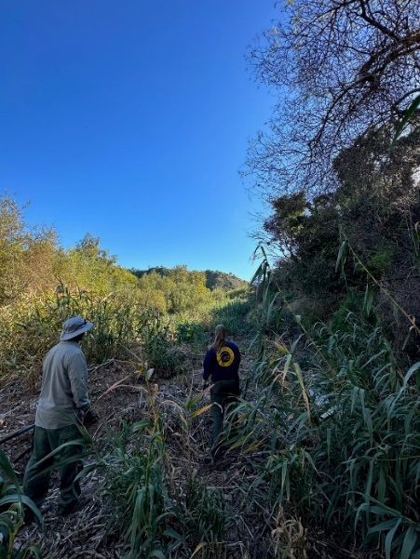

Figure 1: State Parks Natural Resource crew removing invasive giant reed from Lower Topanga. Photo: Dayana Doroteo

Fuel management priorities also include restoring valuable and fire resistance habitat through planting and opportunity. Oak trees, which provide nesting habitat for a wide range of native animals and act as ember catchers during wildfires, are susceptible to extended periods of drought and invasive beetles, invasive shot hole borer beetles (genus Euwallacea) and gold-spotted oak borer (Agrilus auroguttatus). Restoration efforts target areas where oak trees are dying out, recruitment is low, and downed trees create a heavy fuel load. Native grasslands burn slower than invasive thistles and annual grasses, but are often outcompeted due to frequent fires, prolonged drought, and human disturbance. Projects target invasive removal to provide opportunity for native grasses to re-establish.

Roads and trails are regularly brushed on an annual and in some cases, bi-annual basis to provide clearance for public, park, and emergency response vehicles. Vegetation is trimmed along fire roads to the following specifications: 5 feet on either side of the road, where the road has a maximum width of 20 feet, and to 14 feet height clearance.

- DURING THE FIRE: FIRE RESPONSE

All firefighting organizations within California operate under the Incident Command System (ICS), which is the formal administrative structure implemented to organize the complex work force and varied equipment into an effective fire suppression organization. ICS is the organizational structure identified by the Standardized Emergency Management System (SEMS), and the National Incident Management System (NIMS). All response staff should familiarize themselves with the Field Operations Guide to the Incident Command System (# ICS-420-1).

State Parks shall provide an Agency Representative (AREP) and wildland fire qualified Resource Advisors (READs/REAFs) to advise the Incident Management Team (IMT). State Park property boundaries will be included on all Incident maps.

3.1 ORGANIZATION: ICS
The District should split its staff into those who continue to manage parks that are not affected by a fire and those staff who will serve as the AREP, READs, or assist first responders at the incident. Staff at the incident must be fire-trained and will report to the AREP, and/or the Lead READ. The organizational structure presented here is intended for those employees directly involved in the fire.

3.2 STATE PARKS ROLES WITHIN ICS

3.2.1. State Parks Agency Representative or Unified Command
An Agency Representative (AREP) is an individual assigned to an incident from an assisting or cooperating agency who has been delegated authority to make decisions on matters affecting the Agency’s participation at the incident. The State Parks Agency Representative operates within the Command function of the ICS organization. In select circumstances the incident may be co-managed by, in the case of a fire, a fire agency AND State Parks, in which case the State Parks’ Agency Representative will serve as Incident Commander in Unified Command.

The Agency Representative reports to the Liaison Officer or to the Incident Commander in the absence of a Liaison Officer. The State Parks Agency Representative and Lead READ shall assign at least one State Park employee as a READ or REAF to each Division of the fire that involves State Parks ownership. To ensure proper work to rest ratios, it is preferable to have both day and night shifts staffed with State Parks READs.
In addition to the common responsibilities above, the Agency Representative shall:

- Ensure that all agency resources are properly checked in at the incident.
- Obtain briefing for Liaison Officer or Incident Commander.
- Inform assisting of cooperating agency personnel on the incident that the Agency Representative position for that agency has been filled.
- Work with IMT Liaison Officer or Incident Commander to secure Incident Order numbers for all State Parks personnel assigned to the incident.
- Attend all briefings and planning meetings as required.
- Provide input on the use of State Parks resources unless agency technical specialists are assigned from the agency.
- Coordinate with and inform Lead READ of fire progress and fire suppression activities.
- Provide Incident Commander and GIS Specialists with Avoidance Area Maps, State Park boundary information, hazards, and wildfire management objectives, such as allowing areas to burn or fire exclusion areas.
- Coordinate with Lead READ on sensitive resource protection and State Parks’ modified suppression recommendations.
- Cooperate fully with the Incident Commander and the general staff on agency involvement at the incident.
- Ensure the well-being of agency personnel at the incident.
- Advise Liaison Officer of any special State Parks needs or requirements.
- Report to home agency dispatch or headquarters on a prearranged schedule.
- Ensure that all agency personnel and equipment are properly accounted for and released prior to departure.
- Ensure that all required agency forms, reports, and documents are complete prior to departure.
- Have a debriefing with Liaison Officer or Incident Commander prior to departure.
- Maintain Unit/Activity Log (ICS Form 214).

3.2.2. Resource Advisor (READ) / Fireline Resource Advisor (REAF)
When fire suppression activities are expected to impact State Parks ownership it is essential that State Parks provide qualified personnel to fill Resource Advisor (READ) and Resource Advisor - Fireline Qualified (REAF) positions.

A Lead READ shall be assigned to oversee all READ/REAF assigned to the incident. READs shall report to the ICP to advise IMT operations. READs have different areas of professional knowledge, such as cultural, natural, and facilities and collections expertise. Information compiled by the IMT Planning Section may be inaccurate because fire agency staff is likely unfamiliar with ownership and land management objectives. State Parks (through an AREP, READ coordinator or Lead READ) should assign REAFs to each field fire division, each bulldozer, or each falling crew that is operating on State Parks ownership. Consistent guidance given to first responders is essential in working effectively together and building trust between READs and fire fighters. When a READ switches shifts, leaves crew, or leaves a fire, the READ must report guidance and recommendations given to fire division or crew to either the Lead READ or the next READ covering that shift and captured in the ICS 214 Activity Log Form. Newly assigned READs for the day must make sure to be briefed by the Lead READ or previous READ of the shift. It is a READ’s responsibility to make sure they understand the situation and previous READ decisions and give consistent information to responders. READs will be assigned to an incident by the Senior Environmental Scientist Supervisor and the Cultural Resources Program Supervisor or the District Superintendent.
In addition to the common responsibilities above, READ/REAFs shall:

- Stay informed of incident activity, especially emerging incidents and development of incidents within the incident.
- Read Incident Action Plan, attend morning briefings, and incident planning meetings.
- Lead READs will coordinate with AREP to make sure IC has sensitive resource maps, State Park boundaries information, hazards and wildfire management objectives.
- Provide resource management recommendations to protect and serve the resource while being cognizant and sensitive to the objectives of managing the incident. Inform, involve, and prepare.
- Practice good record keeping and documentation. Keep documentation factual, professional, and clear.
- Practice good communication. Check in and provide briefing with Lead READ before and after daily assignments.
- Within the READ organization, conduct or participate in After-Action Reviews.
- Plan for post-incident rehabilitation or restoration, as appropriate.

Avoidance Areas should be shared with the Incident Command, but measures should be taken to keep the information confidential, including tracking and collecting physical maps and flash drives handed out, as well as ensuring that maps shared with the media do not contain sensitive resource data.

3.2.3. State Parks Peace Officer (Ranger)
State Parks Rangers during a wildfire are responsible for notifying Parks’ staff, residences, and visitors of threats, evacuate and close public areas and backcountry areas at risk, staff access to the park to ensure public safety, and law enforcement. A supervising ranger will deliver information from the field to the incident command or AREP about evacuation and manning access status. Rangers are assigned to an incident by the Chief Ranger or the District Superintendent.

Supervising Rangers in all Angeles District parks should have access to the confidential Avoidance Maps and Minimum Impact Suppression Tactics (MIST) guidelines. Avoidance Areas should be shared with the Incident Command, but measures should be taken to keep the information confidential, including tracking and collecting physical maps and flash drives handed out, as well as ensuring that maps shared with the media do not contain sensitive resource data.

3.2.4. Damage Inspection Technical Specialist
Damage inspection includes loss of environmental resources, infrastructure, transportation, or other real personal property. A Damage Inspection Technical Specialist/Resource Advisor is primarily responsible for inspecting damage and/or potential at-risk property or natural resources. The position should be divided by technical expertise: natural resource staff should evaluate soil erosion, tree hazard, exotic species introductions, and retardant pollution; Maintenance staff should evaluate damage to equipment, buildings, utility lines, roads, culverts, bridges, campgrounds; Cultural staff should evaluate archaeological and historic artifact and feature damage; and Peace Officers should focus on managing visitation trespass and looting. For more information, please see the Field Operations Guide to the Incident Command System (# ICS 420-1), which provides both general and specific responsibilities of Damage Inspection Technical Specialists. Qualified READs can also fill this role.

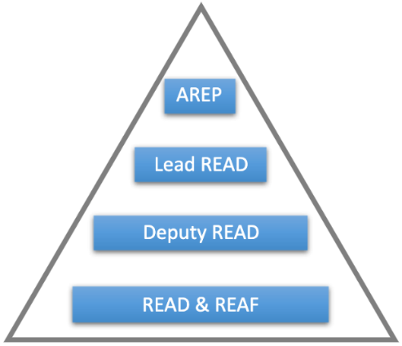
Figure 2: Hierarchy of the AREP-READ team within State Parks.

3.2.5. Geographic Information Systems Specialist (GISS)
This position is typically filled during Type 1 or 2 fires with a fire agency employee. If State Parks District has a GIS specialist, that person could interact with the GISS to supply State Parks GIS data important to the incident. However, if the fire is almost solely within a large park, the State Parks GIS person may be the best candidate for the GISS position.

A Technical Specialist (GIST) is responsible for GIS collection, display analysis, dissemination. The GIST will provide GPS support, integrate infrared data, and incorporate all relevant data to produce map products, statistical data for reports and/or analysis. The GIST should make sure all relevant State Parks boundaries will be included on every incident map, hard copy and digital copy.

3.2.6. Field Observers (FOBS)
Field Observers provide critical information to the Incident management Team. Qualified local State Park staff may be assigned to the incident as Field Observers or work in tandem with a Field Observer to collect and transmit data to the IMT.

3.3 COMMON RESPONSIBILITIES OF ALL ICS PERSONNEL
Regardless of whether State Parks staff arrives before or after the fire suppression personnel, State Parks employees have several duties to discharge within the context of management of the incident.
  - Closure of fire-involved area to the public (Peace Officer function). This activity is necessary when unauthorized members of the public are at the fire scene (CPC 409.5).
  - Evacuation of visitors, lessees, and employees and their dependents (authorized by the District Superintendent when their safety is threatened)
  - Law enforcement (Peace Officer function).
  - Protection of State Park System structures and developments (READ/REAF function).
  - Protection of sensitive State Parks natural and cultural resources (READ/REAF function)
  - Initial attack. State Parks staff with firefighting training and Personal Protective Equipment may directly suppress an uncontained fire. When engaged in initial attack activities, State Parks staff must take care to preserve any evidence at the point of origin.
  - Maintain Unit/Activity Log (ICS Form 214).
Some State Parks employees, those with Fire Fighter Type 2 training, may be involved in the protection of State Parks structures and indirect attack, consistent with training and ideally within a policy framework established by Division and Policy Chiefs.

All State Parks employees assigned to a wildfire incident have common responsibilities within the ICS protocols. These are:
  - Receive assignment from your agency, including:
    - Job assignment
    - Resource Order number and request number
    - Reporting location
    - Reporting time
    - Travel instructions
    - Any special communications instructions
    - Note: REAFs – should not go out on the fireline without a resource order number
  - Upon arrival at the incident, check in with check-in status recorder. Designated Check-in locations may be found at:
    - Incident Command Post (ICP)
    - Base or camps
    - Staging Areas
    - Helibases
    - If you are instructed to report directly to a line assignment, check in with the Division/Group Supervisor.
  - Receive briefing from immediate incident supervisor.
  - Acquire work materials.
  - Organize brief subordinates
  - Use clear text and ICS terminology (no codes) in all radio communications. All radio communications to the Incident Communications Center will be addressed: “(Incident Name) Communications”.
  - Complete forms and reports required of the assigned position and send through incident supervisor to Documentation Unit.
  - Respond to and brief subordinates regarding demobilization orders

3.3.1. Incident Command Post Safety and Attire
Firearms are prohibited in several areas of the ICP due to presence of inmate crews. Peace Officer Protective Equipment (POPE) shall not be worn in these areas of the ICP. It is critical that peace officers serving in any role at the ICP obtain the ground rules for the ICP on weapons and other conditions requiring modified duty wear. All employees shall otherwise wear the appropriate standard field uniform while at the ICP.

3.3.2. Documentation
Wildfires that burn on State Park lands shall be documented by State Park qualified personnel using the ESRI Field Maps application. Maps created by fire protection agencies after a large wildfire should be field checked and transferred to a GIS layer.

READs, REAFs, and other responding State Parks employees with an ESRI account may utilize ESRI smart phone applications to collect data on Suppression Impacts and Repair for the Statewide database.

A detailed Wildfire Data Collection tutorial can be found in APPENDIX F.

3.3.3. Media
The State Parks Angeles District Superintendent and Chief Angeles District Ranger handle all media requests. State Parks employees should not make comments or statements to media personnel. AREPs, Supervising Rangers, and READs at Incident Command should make sure Avoidance Area maps and information are kept confidential and media personnel aren’t granted access and do not take pictures or videos of maps with sensitive park resource locations.

3.4 RESOURCES FOR DETECTING AND TRACKING WILDFIRES
The following resources should be utilized to notify State Parks employees of wildfires on or threatening State Park property:
Phone Applications:
- Watch Duty – provides wildfire location, acres, % containment, status, and live updates about current fires in the western United States (Washington, Montana, Wyoming, Oregon, Idaho, California, Nevada, Utah, Colorado, and Arizona).
- PulsePoint – Emergency notifications and alerts for the United States. Filter by location, emergency type, and responding agency. Provides wildfire location, assigned unites and current status (cleared, enroute, onscene), responding agency radio.
Websites:
- ALERTCalifornia – https://alertca.live/cameras. Live cameras across California to view wildfire progress. Can watch live and see up to 12 hours previously.
- National Wildfire Coordinating Group and INTTERRA maps – https://maps.nwcg.gov/sa/#/%3F/%3F/34.4661/-118.3639/12. View current locations of wildfires in California and locations of weather stations. Limited information for initial attack phase, but details for extended attack, such as % containment, management organization (fire type), acres, cause, total personnel, and landowner.
- Southern California Geographic Coordination Center (OSCC), Predictive Services – https://gacc.nifc.gov/oscc/predictive/weather/. Provides seven-day outlook for fire potential in each zone of Southern California. Additional resources such as monthly/seasonal weather outlooks, daily wind impacts, and wildfire threat indices.
- National Weather Service, California Fire Weather - https://www.weather.gov/wrh/CAFW. Current Fire Weather Watch and Red Flag Warnings for California.

3.5 WILDFIRES THREATENING A STATE PARK
When a large uncontained fire cannot be directly suppressed (attacking the head of the flaming front), the fire suppression agencies may send equipment and personnel well ahead of the flaming front to establish fire control lines (called the Contingency Branch). District/Sector shall assign a District employee to perform the function of State Parks Agency Representative (AREP) to the Incident Command Post of any fire in the vicinity of State Parks ownership which is not contained. State Parks boundaries shall be included on all incident maps for wildfires threatening State Park property and being assessed by Contingency Branch.

An AREP and READ will be consulted before executing any contingency operations on State Park property.

Typically, if a fire threatening State Park land is still in initial attack phase, park staff do not report to the incident. Determining if a District employee should serve as an AREP and report to the incident depends on several factors:
- Proximity of the fire to a State Park
- Weather: direction and strength of wind, humidity, temperature, days since last rain
- Terrain, vegetation type, and fuel load
- Percent containment
- Resources called onto fire: dozers and heavy equipment on scene
- Sensitive resources at risk and within the fires path
Fire trained State Park staff should share and discuss the above information and determine who, if anyone, should arrive at the incident. If it is determined necessary, a schedule of 12-hour shifts and relieving staff should be made in case the fire extends onto State Park property. Should the fire later be determined not to be a threat, State Park staff should notify their immediate supervisor that they are leaving the fire. Documentation is not necessary for fires not on State Park land unless suppression activities ahead of the fire are conducted on park property.

3.6 WILDFIRES ON STATE PARKS LANDS
For all fires involving State Park property, the District Superintendent shall assign/request qualified and equipped AREPs and READ(s) will be assigned to the incident, given O (Overhead) or E (Equipment) numbers, and will attend planning meetings, and briefings.
If no READs or REAFs from the park unit’s district are available or more READs are needed, the District Superintendent may request out-of-district assistance (please see the Out-of-District Request Protocol in APPENDIX E).

Field positions should be staffed as soon as possible, in order to promote efficient coordination with the IMT and to prevent unnecessary damages to State Parks resources.

Information about State Parks lands that are likely to be affected shall be supplied to the Planning Section Chief and the Situation Unit leader. These positions are responsible for the collection and organization of incident status and information, and the evaluation, analysis, and display of that information for use by all personnel. All relevant State Parks boundaries shall be included on every incident map, hard copy and digital copy. The State Parks AREP, Lead READ or their designee will supply information about State Parks ownership boundaries, cultural and natural resource avoidance areas, hazards, access, and other fire control features that the Planning Section may need for the next operational period. It is preferable to have this information in both hard copy and GIS format electronic copy. State Park boundaries shall be included on all incident maps for wildfires involving State Park property.

To ensure State Park personnel are involved in the response planning, the AREP should arrive on scene as soon as possible. In most cases a ranger is the first to arrive, make contact with the responding agency, and takes on the role of AREP. It is the AREPs duty to contact appropriate State Park personnel, such as supervising rangers, district superintendent, and READs, and inform personnel of the fire’s progress, potentially affected resources, and public safety concerns. READs need to be at the incident as soon as possible to provide maps of avoidance zones and ensure the protection of sensitive resources. Direct and timely communication between fire trained State Park staff is critical.

3.6.1 Initial Attack
Any employee first on scene to report a fire shall communicate information regarding a confirmed wildfire using the Emergency Fire Telephone Directory on page 1 and follow the procedures in section 1 for sizing up the incident. If multiple State Parks employees are the first to arrive at an uncontained wildfire, the highest-ranking State Parks public safety employee shall designate an Incident Commander, typically the employee with the most ICS training and experience. This person will oversee the incident until relieved by a State Parks Agency Representative and the responding agency.

Most fires that start in State Park land, remain in the initial attack phase and the IC is formed by the responding agencies commander. It is imperative that State Park staff, AREP and supporting READs, arrive on scene as soon as possible to direct responders away from avoidance areas and assist in the planning.

3.6.2 Extended Attack
The extended attack phase is a determination made by the responding agency after it has assumed ICS authority of the incident. During the extended attack phase, State Parks is primarily involved in advisory ICS duties through AREP, READ, and REAF roles, although some State Parks employees may be involved in public and collections evacuations, fuel reduction efforts and/or protection of State Parks structures or other resources once assigned to the incident.

An extended attack is normally characterized by:
- Not expected to be contained/controlled within the first operational period.
- No written Incident Action Plan.
- May have a small incident base established and some command functions staffed.

If an uncontained wildfire is either on or threatening State Parks lands, the District Superintendent must assign an employee to the ICP as a State Parks AREP. This person must have authority to speak for the Department and shall report either directly to the Incident Commander (small fire) or to the ICS Liaison Officer (large fire). The State Parks AREP shall assign properly trained and equipped employees (REAFs) to monitor suppression activities by fire response agencies. This is typically done in consultation with District Core Staff.

The State Parks Agency Representative may assign properly trained and equipped employees, such as members of the Fire Management Program, to monitor suppression activities and protect the exterior of State Parks structures, assuming advance lead time is available to safely deploy and demobilize these resources ahead of the fire.

3.6.3. Large Fires - ICS Type 1 and Type 2 Organizations
Federal fire suppression agencies and CAL FIRE have established Type 1 and 2 IMTs to manage large-scale wildfires. These teams are composed of individuals from various agencies and from locations around the country or state respectively. It is likely that people not familiar with the local area will manage large-scale wildfires that impact State Parks.

A rapidly expanding fire, and the concurrent large influx of fire suppression equipment and personnel has a great potential to damage State Park resources and can overwhelm district staff. The District Superintendent may request out-of-district assistance for a variety of tasks necessary for incident response and maintaining other district functions through the Department Headquarters Emergency Operations Center, if established, or the Chief of the Law Enforcement and Emergency Services Division when there is a Type 1 or 2 incident on or threatening State Park property.

Type 2 Organization is the first level at which most or all the command and general staff positions are activated and are filled by a Type 2 Incident Management Team. A Type 2 organization has the following characteristics:
- Supervises a large organization.
- Multiple operational periods.
- Gathering information to develop a written Incident Action Plan.
- Providing logistical support including operational base and camps.

A Type 2 Incident will require an AREP, Lead READ, and multiple READs, and REAFs as necessary.

Type 1 Organization has all the characteristics of a Type 2 Organization plus:
- All command and general staff position are filled with Type 1 qualified people.
- The number of division/groups may require the Branches be activated to accommodate span of control needs.
- Operations personnel exceeds 500 per operational period and total personnel exceeds 1000.
- Aviation operations often involve several types and numbers of aircraft.

A Type 1 Incident will require an AREP, Lead READ, Deputy READ, and multiple READs, and REAFs as necessary, to cover day and night operational shifts to ensure proper work to rest ratios.

3.6.4. Fire Safety and Qualifications
Those State Parks employees who have been authorized by the District Superintendent to work on a wildland fire incident must, at a minimum, have received Fire Fighter Type II Training (Basic 32), be current with their Annual Wildland Fire Safety Refresher Training (RT-130 and required pack test) and must wear approved Personal Protective Equipment that meets National Fire Protection Association (NFPA) 1977, Standard on Protective Clothing and Equipment for Wildland Fire Fighting:
- Hardhat
- Face and Neck Shrouds
- Eye Protection
- Leather fire rated gloves
- Nomex Shirts & Pants (no coveralls or jumpsuits due to heat stress potential)
- Boots
- Fire Shelter
In accordance with CAL OSHA regulations (Title 8, General Industry Safety Orders, § 3410), additional equipment should include:
- Wildland fire line pack (web-gear)
- Hand Tool
- Writing utensil and sharpie, pocket note pad
- Headlamp
- Water bladder bag/water bottles
- Belt weather kit or digital weather monitor
- Compass
- First aid kit
- GPS unit/GPS app on your smart phone/mobile mapping app
- Lighter/matches
- Extra Batteries
- Radio chest harness
- Incident Response Pocket Guide (IRPG)
- Incident approved radio
- Flagging – READs and AREPs will use blue striped or checkered flagging to notify areas for avoidance and to not be confused with fire fighter flagging. Clarifying notes should be written on the underside of the flagging in sharpie/pen.
- Gear bag (red bag)

3.6.5 Modified Fire Suppression and Values at Risk
The CalFire/State Parks Interagency Agreement (Appendix D) gives CalFire or its agent the authority to use modified suppression techniques on State Park lands.

Developed areas and structures are usually the principal values at risk; these are values that will be destroyed or damaged by an advancing wildfire. However, State Parks is mandated to also protect historical, archaeological, paleontological, and natural resources. The fire itself can destroy wooden historic structures and it may produce short term damage to natural resources, however, in many cases, it does not damage the soil and thus low intensity fire may leave archaeological and paleontological resources intact.

Conversely, fire suppression activities that disturb soil will permanently destroy shallow archaeological and paleontological resources, may produce long-term damage to the plant communities, increase or introduce invasive plant species, and promote erosion and sedimentation. Exotic and invasive vegetation can spread through dozer lines caused by suppression activities, forever changing the natural landscape of the park unit.

California law provides for very strong immunity for its agencies and employees while conducting firefighting and related activities (GC § 850.2 & 850.4). The laws are weighted in favor of controlling a wildfire as quickly as possible, however this does not preclude indirect attack and other modified fire suppression alternatives provided “due diligence” is exercised. State Parks desire to apply modified fire suppression does not jeopardize any agencies or employee’s immunity so long as the alternative methods for fire control recommended by State Parks are equal to or superior in their contribution to the success of controlling the fire as those methods proposed by the fire protection agency.

Large fuel breaks in natural areas are also not effective in stopping the leading front of wind driven crown fire, thus their establishment is restricted by State Park policy (DOM § 0313.2.1.2.1). Repetitive use of standard fuel breaks will create negative cumulative impacts on the property. State Parks long term management goals include ecological fuel breaks, which are alternative forms of fuel breaks that do not result in habitat fragmentation and invasive annual grasses. Long term management must shift priority from standard fuel breaks in natural areas to specified fuel breaks that are ecologically fit and consistent with the area being prepared and protected. Multiple types of fuel breaks may be chosen, these include shaded fuel break, mow line, hand line, wet line, dozer line, black line, and mastication line. Examples are found below, and definitions can be found in the Glossary.

See chart below to help decide what type of fuel break can be utilized for fire prevention and suppression. Prescribed fire use, if appropriate to the area’s natural fire regimes, should be encouraged for fuel reduction and creating black line (a strategy during wildfires).

Table 5. POTENTIAL LINE IMPACT TABLE
 | MOW  LINE | WET  LINE | BLACK  LINE | MASTICATION  LINE | HAND  LINE | SHADED  FUEL BREAK | DOZER  LINE
SOIL  DISTURBANCE | Minimal | Minimal | Minimal | Medium to  Heavy | Medium | Minimal to  Medium | Heavy
MACHINERY  NEEDED? | Yes | No | No | Yes | Sometimes | Sometimes | Yes
REAF OVERSIGHT  PRIORITY | No | No | Yes | Yes | No | Yes | Yes
LEVEL OF AVOIDANCE  AREA : ALLOWABLE | Highly  Sensitive:  Top Tier | Highly  Sensitive:  Top Tier | Depends on  Sensitive  Resource | None  in Avoidance  Area | Middle Tier | Middle Tier | None  in Avoidance  Area

As each wildfire season becomes more severe and destructive, a park unit cannot receive continuous emergency-level fire suppression without losing its natural and cultural integrity. Fuels reduction projects can help reduce potential fire severity while achieving resource objectives of returning vegetation and fuel loads to within the range of conditions found in historic fire regimes. In many circumstances fuel breaks seek to maintain vegetative conditions that fall outside of the normal range of conditions for that vegetation type. Fuel breaks on State Park property that compromise an area’s natural condition are therefore inconsistent with State Park objectives in most areas and should be discouraged. If fuel modification is critical and a fuel break is determined to be the only feasible method of fuel modification for a specific area, then such a fuel break shall be designed to meet fuel reduction goals with minimal impact on esthetic and ecosystem values.

Maps of avoidance areas/areas of concern (previously discussed in this document) should be provided to fire response agencies and personnel and may be included on relevant incident maps. Maps should be provided as hard copies and digital copies. Pre-planned dozer lines in pre-planned areas (explicitly written in the LOA) may become lower priority for staffing resource advisors for heavy equipment operations. Pre-planned dozer lines give State Parks more confidence in response agencies’ ability to protect sensitive resources. The AREP and REAFs will prioritize on collaborating with suppression personnel to repair resources during the incident rather than after the incident.

State Parks desires to implement managed burns; managed burns refer to wildfires that strategically burn out with contained borders and appropriate oversight if and when possible. Managed burns can be used to reduce the chances of future catastrophic or hard to control fires and can achieve ecological and other objectives consistent with the California State Parks mission. Parks often achieve these objectives using prescribed fire and wildfires can achieve the same results, especially in the shoulder season. These objectives can also be implemented with backfiring off of fire roads during a wildfire event. This is preferred over hand lines around the fire perimeter in Topanga State Park because it reduces the need for dozer lines as an escape route for hand crews, makes use of already established fire roads as control lines, and allows accumulated fuels between control lines and the main fire to burn. The final decision to modify suppression action will be based upon:
- The probability of threat to life and/or property
- The availability of fire suppression resources
- The magnitude of fire expansion as determined by the Incident Commander
- Current and expected fire behavior and weather
- Fuel loads as determined by recent adjacent wildfires or prescribed fires
- The likelihood of success in achieving park objectives

Modified Suppression Criteria:
Hazardous Trees:
- Only cut down trees that are a hazard to firefighters working on the line or a fire risk.
  - Do not buck up trees into small logs.
Hot-line/Ground Fuels:
- Allow fire to burn to natural barriers.
  - Allow fires to back into, around, or through wetlands and meadows to avoid suppression damage.
  - Where wetlands are used as a natural boundary to help contain a fire, the control line will be sited outside the wetland area. Trample lines (rather than dug lines) may be used if it is necessary to site the control line in a wetland.
- Use cold-trail, wet line or combination when appropriate.
- If constructed fire line is necessary, use only width and depth to check fire spread.
- Burn out and use low impact tools like swatter or ‘gunny’ sack.
- Minimize bucking and cutting of trees to establish fire line; build line around logs when possible.
- Minimize felling of trees and snags unless they threaten the fire line or seriously endanger workers.
  - In lieu of felling, identify hazard trees with a lookout or flagging.
- Scrape around tree bases near fire line if it is likely they will ignite.
- Use alternative mechanized equipment such as excavators, rubber-tired skidders, etc. rather than tracked vehicles.
- Use high pressure type sprayers to clean equipment prior to assigning equipment to the incident command in order to reduce the potential to spread noxious weeds.
Mop-Up:
- Modified mop-up for ground fuels should be utilized where possible:
  - Minimize spading, restricted to hot areas near the fire lines.
  - Cold-trail charred logs near the fire line with minimal tool scarring.
  - Minimize bucking of logs to extinguish fire or to check for hotspots. Roll logs instead of bucking where possible. Return logs to original position after checking and when ground is cool.
  - Consider allowing large logs to burn out. Use a lever rather than bucking to manage large logs that must be extinguished.
  - Refrain from making bone yards; burned and partially burned fuels that were moved should be returned to a natural arrangement.
  - Consider using infrared detection devices along perimeter to reduce risk.
  - Personnel should avoid using rehabilitated fire lines as travel corridors whenever possible because of potential soil compaction and possible detrimental impacts to rehab work, i.e. water bars.
  - No mop-up techniques are allowed in avoidance areas without the presence of an archaeologist READ. Modified mop-up techniques must be implemented to reduce the risk of damaging cultural resources.
- Reduce impacts to aquatic resources:
  - Except in emergency situations, water drafting from park streams and creeks that support salmonids must be halted when water levels drop to a level that could result in disconnected pools of water in the channel. Any water pumping from salmonid streams will require measures to prevent injury to fish, such as using offstream sumps, restricting approach velocities to less than 0.8 foot per second, and screening at intake with openings no greater than 0.25 inch.
  - Use gravity socks in stream sources and/or a combination of water blivits and fold-a-tanks to minimize impacts to streams.
- Modified mop-up for aerial fuels should be utilized where possible:
  - Remove or limb only those fuels which if ignited have potential to spread fire outside the fire line.
  - Before felling consider allowing ignited tree/snag to burn itself out. Ensure adequate safety measures are communicated if this option is chosen.
  - Identify hazard trees with a lookout or flagging.
  - If burning trees/snags pose a serious threat of spreading fire brands, extinguish the fire with water or dirt whenever possible.
  - Align saw cuts to minimize visual impacts from more heavily traveled corridors. Slope cut away from line of sight when possible.
Aviation Use Guidelines:
- Maximize back haul flights as much as possible.
- Use long line remote hook in lieu of constructed helispots for delivery or retrieval of supplies and gear.
- Take precautions to insure noxious weeds are not inadvertently spread through the deployment of cargo nets and other external loads.
- Use natural openings for helispots and paracargo landing zones as far as practical. If construction is necessary, avoid high visitor use areas.
- Consider maintenance of existing helispots over creating new sites.
- Obtain specific instructions for appropriate helispot construction prior to the commencement of any ground work.
- Habitats of sensitive aquatic species, such as wetlands, streams should be avoided when saltwater is used.
READs/REAFs and AREPs will use blue striped or checkered flagging to notify areas for avoidance and to not be confused with fire fighter flagging. Clarifying notes should be written on the underside of the flagging in sharpie/pen

3.7 Invasive Species Mitigation During Fire Suppression
California State Parks spends significant time and money each year controlling and reducing the spread of invasive plant species that threaten native habitats, sensitive wildlife and plant species, and rare plant communities. In many California ecosystems the spread of invasive species is exacerbated by wildfire and fire suppression activities. Increased fire frequency in chaparral and native grassland communities can cause type conversion to exotic grasses. Invasive grasses which die off earlier in the year and have a comparatively high surface area-to-volume ratio more easily ignite and rapidly spread wildfire compared to native plants, contributing to a shorter fire interval and high intensity fires. Many of these species thrive in disturbed landscapes and quickly colonize post wildfire, particularly old dozer lines, hand lines, and the edges of roadways. The combined effect of which creates a cycle that encourages exotic grasses to establish and spread. In riparian habitats, which usually act as natural barriers during wildfires, exotic plant species can increase the likelihood of wildfire and push out native plants as invasives more quickly recover after disturbance. Additionally, heavy equipment and fire vehicles help the dispersal of invasive seeds as they extensively travel around a State Park during a wildfire.

It is imperative that wildfire suppression activities do not facilitate the spread of invasives, and measures are taken to protect native species and communities that may be outcompeted and threatened. To help notify first responders to areas with known invasive infestations, invasive species zone maps are listed in appendix X.

To reduce the spread of invasive species, first responders should take the following measures where possible:

Suppression:
- Use high pressure type sprayers to clean equipment prior to assigning equipment to the incident command in order to reduce the potential to spread noxious weeds.
- All vehicles should be pressure washed, including wheels and undercarriage, before entering State Parks land.
- All vehicles that must go through an invasive species zone must be pressure washed, including wheels and undercarriage, immediately after exiting the infestation.
- All helicopter pick ups should be staged on concrete or tarped areas to reduce the risk of seed dispersal.
- Prevent wildfire from reaching the lower Topanga Creek and riparian habitat in Compartment 3 where large patches of invasive giant reed are present and endangered steelhead habitat is at risk.
Repair:
- Vegetation used to repair and cover dozer and hand lines should first be approved by a READ to make sure no invasive species are being added.
- Any dead material approved for chipping should be chipped in place to reduce the spreading of invasive insects, unless approved by a READ.

3.8 COMPARTMENTS AND COMPARTMENT MAPS
Features of the different compartments require different protections and management goals during a wildfire. Allowable suppression tactics in each compartment depend on the number of sensitive resources, vegetation type, WUI areas, and accessibility. Suppression tactics allowed in each compartment are listed below along with special considerations such as hazards.

Many of the structures within Topanga State Park are historical and require additional protection to keep from burning. Table X. lists all structures within the park and their priority level for protection. Structures rated as high priority should have the most preventative measures in place annually and should be taken into consideration when planning and carrying out fire suppression activities in the park. Where a high priority structure overlays an avoidance zone, preventive measures to keep structures from burning and suppression measures around the surrounding area to keep the area from burning, will be needed.

Table 6. PRIORITY AREAS FOR PROTECTION
Compartment | Location | Type | Description | Protection Priority Level
2 | Trippet Ranch | Main residence | Historic Trippet Ranch, current employee residence | High
2 | Trippet Ranch | Nature Center and Historic Skeet Lodge | Exhibits and collections | High
2 | Trippet Ranch | Office | Ranger and Maintenance Office | Medium
2 | Trippet Ranch | Visitor facilities | Park entrance station | Medium
2 | Trippet Ranch | Maintenance Facility | Garage and sheds | Low
2 | Trippet Ranch | Visitor facilities | restroom, picnic area, parking | Lowest
2 | Topanga Residence Road | Residence | Modular unit | High
2 | Topanga Residence Road | Residence | Stand-alone near Musch Camp | High
2 | Musch Camp | Residence | Residence | High
2 | Musch Camp | Campground | Campground, restroom, corrals | lowest
2 | Dead Horse Trailhead | Visitor facilities | Restroom, parking | lowest
3 | Lower Topanga | Lower Topanga Residence | Historic Ranch Motel, current staff residence | High
3 | Lower Topanga | Topanga Ranch Motel Cabins | 25 historic cabins | High
3 | Lower Topanga | Lower Topanga | Cholada Thai Restaurant  The Malibu Feed Bin  Reel Inn Malibu  Wyle's Bait& Tackle  Rosenthal Wine Bar & Patio  Oasis Imports | High
3 | Los Liones Drive | Visitor facilities | Restroom, parking | lowest
4 | Temescal Ridge Fire Road | LA-RICS Green Mountain Facilities and Equipment | LMR CMU equipment shelter, LMR Racks, 120-foot-tall Tower, LMR and LTE Antennas, LMR Microwave Dishes, LMR Diesel Fuel Tank and Generator | High

3.8.1 Compartment 1 [Garapito]
Compartment Description
The majority of compartment 1 has not burned in over 50 years and has accumulated a heavy fuel load. Where possible, State Parks would prefer to allow a managed burn in this compartment.
Hazards
LADWP has several powerlines that run through the compartment. A powerline runs along the majority of Dirt Mulholland at the northern end. Another powerline runs along Bent Arrow Trail, crossing and continuing southwest parallel to Temescal Fire Road to Hub Junction. An underground petroleum pipeline begins at the intersection of Dirt Mulholland and the Caballeo Canyon Trail and runs north into the valley. See compartment maps for hazard locations.
Safety Areas
A Potential Safe Refuge Area within compartment 1 is at the junction of Fire Road Thirty and Garapito Canyon Trail/ Bent Arrow Trail. The top of Reseda Blvd provides a vantage point.
Suppression Tactics
The Palisades fire in 2021 started in compartment 4 and moved northward into compartment 1 and 2. Dozer lines are still visible on the landscape and several are being used as illegal bike and hiking trails. To reduce the risk of more inadvertent trails being made, old and unrepaired dozer lines should be used in replace of cutting new lines. To allow additional acres to burn, where possible, established fire roads should be used for backfires rather than sending down hand crews to the fire’s edge. This should reduce the number of dozer lines needed and reduce the natural fuel load.

3.8.2 Compartment 2 [Trippet]
Compartment Description
Compartment 2 holds most of the cultural resources in the park and is surrounded by the community of Topanga. It is imperative to reduce the risk to public safety and protect valuable sensitive resources by treating this compartment as a fire exclusion area.
There are two day use areas in the compartment, Trippet Ranch Parking Lot and Dead Horse Parking Lot. There is one backcountry campground, Musch Camp. There are four residences, Historic Superintendent’s House at Trippet parking lot, two residences at the end of Topanga Residence Road, and one at Musch Camp.
Cultural Resources
The Topanga Cultural Preserve holds historical structures, Native American sites, and many historical artifacts. Preserving these resources from fire suppression damage and burning is the top priority for this compartment.
Hazards
Trippet Ranch: There are two liquefied petroleum gas (LPG) tanks by the Trippet Ranch residences at the end of Topanga Residence Road. Each tank is located near the side of the buildings. Trippet parking lot has one LPG tank and one electrical meter on the south side of Entrada Road between the residence and the entrance kiosk. The electrical main is located just before the kiosk. There are many powerlines surrounding Trippet Ranch in neighboring communities. An SCE electrical transformer powers the area and is located on the south side of Entrada Rd. behind the maintenance building. The maintenance and ranger garage houses mechanical equipment and chemicals. A certified flammable liquid storage shed houses fuel for mechanical equipment and is located next to the maintenance office.
Dead Horse Parking Lot: There is one electrical meter before the gate.
Musch Camp: Along Musch Trail from Trippet Ranch is a group of structures including a tool shed for water-based paint.
Suppression Tactics
Due to the many sensitive cultural resources in the Topanga Cultural Preserve, no bulldozing or hand lines are allowed in the preserve. To reduce the loss of structures in a fire and having to conduct suppression activities in the preserve, efforts should be made to protect fire from reaching the preserve. An archeologist READ is required for all fire suppression activities in or near the preserve.
Special Considerations
Public Safety
Access to the main entrance at Trippet Ranch is through narrow, windy paved roads. During an evacuation, traffic may back up in these neighborhoods and onto the two-lane Topanga Canyon Blvd (State Hwy 27) that is one of the main corridors through the mountains to PCH at the south and the State Hwy 101 at the north. Furthermore, the community of Topanga is almost entirely a WUI area. Many of the structures along Topanga Canyon Blvd are surrounded by trees and tall shrubs that without proper defensible space measures, may make home ignitions likely and property protection difficult. These structures include private homes, businesses and the Topanga Elementary School. Topanga Creek runs parallel with Topanga Canyon Blvd and many houses have private one-way bridges to their properties that may be a fire hazard and complicate evacuation and suppression efforts should bridges be compromised or weight constricted.
Facility Resources
Facilities within Compartment 2 are listed above with their level of priority for protection against fire. Compartment facilities hold historical and maintenance value to the park and many are listed as high priority for protection. Trippet Ranch critical structures consist of a residence, two administration buildings including the ranger station office and the maintenance shop, and the nature center in the historic Skeet Lodge. Two residences are accessible from Trippet Ranch parking lot down the Topanga Residence Road. There is a residence and garage at Musch Camp.

3.8.3 Compartment 3 [Lower Topanga]
Compartment Description
The biggest priority for compartment 3, is protecting Topanga Creek from heavy sediment flow due to wildfire caused erosion. While Topanga Canyon Hwy runs parallel to the creek, narrow canyon-like banks and steep slopes, make accessing the surrounding ridges difficult. The best methods for reducing the erosion risk are most likely preventative or repair, rather than during fire suppression.
Cultural Resources
There are several cultural sites within a .75 mile radius of Topanga lagoon. Hand lines, dozer lines, and any other forms of soil disturbance are not permitted in avoidance areas. An archeological READ is required for all fire suppression activities near avoidance areas.
Natural Resources
Two federally endangered species and one threatened species depend on Topanga Creek for habitat. Southern steelhead trout spawn upstream in shallow pools. Tide water goby and California red-legged frog are found in Topanga lagoon. If burned slopes remain baren after heavy rain, large amounts of sediment may sweep through the creek, washing and choking out these sensitive species. A READ is required for all fire suppression activities within and surrounding Topanga lagoon to protect these sensitive species.
Hazards
The Topanga Ranch Motel and cabins each have wall mounted gas furnaces that are past the recommended equipment lifespan. There is one gas meter on the first building to the east when entering the complex. Cabins are in states of dilapidation. The Topanga Lagoon Restoration Project may change hazards as old structures are renovated, new facilities are added, and public accessibility increases. Wildfire management maps and documents will need to be updated as the project progresses.
Suppression Tactics
No retardant is allowed in Topanga Creek. No water may be pumped from Topanga lagoon to protect federally endangered aquatic species. Filters must be used if water is pumped from a natural creek or pond. READs are required for all suppression activities within a mile of Topanga Lagoon, in State Park land.

3.8.4 Compartment 4 [Santa Ynez]
Compartment Description
Approximately 1,203 acres burned in the upper portion of compartment 4 in the Palisades fire of 2021. Multiple dozer lines left over from the fire still remain and are now being used as illegal trails. To prevent new illegal trails from being formed and to reduce impacts from fire suppression, fire roads and old dozer lines should be used in place of building new lines. Because chaparral can take several decades to fully recover, the northern half of the compartment should be kept from burning to allow the landscape to fully recover.
There is one day use lot, Los Leones Parking Lot on the southern end of the compartment. Water fountains and restrooms are the only facilities.
Cultural Resources
There are several cultural sites within the compartment. Many of these are clustered along the Santa Ynez Canyon area. No suppression activities that create soil disturbance are allowed in cultural sites. An archaeologist READ must be consulted near avoidance areas.
Natural Resources
There are several endangered plant species in the compartment, some of which are along East Topanga Fire Road, Temescal Ridge Trail, and Trailer Canyon Fire Road. A READ must be consulted before hand or dozer lines are created near these areas.
Hazards
The Los Angeles Regional Interoperable Communications System Authority (LA-RICS) has a lease on Green Mountain within the park and accessed from Temescal Ridge Fire Road. The LA-RICS site contains Land Mobile Radio (LMR) facilities and equipment, including an LMR CMU equipment shelter with mounted GPS antennas (6), LMR R indoor RF Racks (12), DC Rack (2), Battery Racks (2), Future Racks (3), 120 foot tall self-supporting Tower with a 15' lightning rod, LMR (22) Antennas, LMR (3) Microwave Dishes, LMR Diesel Fuel Tank and Generator with CMU wall enclosure, and LTE ( 12) Panel antennas.
Suppression Tactics
State Parks’ preference is to use old unrepaired dozer lines over forming new dozer lines. Topanga Creek runs partway through the compartment parallel with Topanga Canyon Hwy before crossing under into compartment 3. Retardant drops are not allowed over the creek and adjacent slopes, and water should not be pumped from the creek. To protect the federally endangered plant species and several cultural sites, a READ must be consulted for any hand lines or dozer lines coming off East Topanga Fire Road, Trailer Canyon Fire Road, Temescal Ridge Trail, and the southern portion of Santa Ynez Canyon Trail.

3.8.5 Compartment 5 [Temescal]
Compartment Description
Compartment 5 consists of chaparral that has not burned for over 50 years and there is a heavy fuel load. Where possible, State Parks would prefer to allow the area to burn. Will Rogers State Historic Park sits south of compartment 5 and protects numerous historical buildings. Keeping a wildfire from spreading from Topanga State Park into Will Rogers State Historic Park is a top priority.
Public Safety
Adjacent to the eastern border of Compartment 5 is the city owned Murphy Ranch and the privately run Camp Josepho, which both rely on Sullivan Ridge Fire Road as an ingress/egress. While Murphy Ranch is no longer occupied, the trials and abandoned buildings receive a moderate level of recreational use by day hikers. Should a wildfire threaten the area, the property and nearby trails will need to be evacuated. Abandoned buildings may also pose a threat to first responders. Buildings are in a derelict state with rusty metal and broken glass within and around the structures. The area is a popular place for graffiti and spray cans and other trash may be present. Camp Josepho holds camps during the summer months and relies on Sullivan Ridge Fire Road as entry and exist. During a wildfire it is imperative that the Camp is evacuated with enough time to give campers and hosts time to clear the area.
Cultural Resources
There are several cultural sites on the eastern edge of the compartment within Rustic Canyon. A READ must be consulted for suppression activities near avoidance areas.
Natural Resources
There are several endangered plant species in the compartment, some of which are along fire roads. A READ must be consulted before hand or dozer lines are created. Suppression Tactics
To allow additional acres to burn, where possible, established fire roads should be used for backfires rather than sending down hand crews to the fire’s edge. This should reduce the number of dozer lines needed and reduce the natural fuel load.

3.9 INCIDENT COMMAND POSTS (ICPs) AND FIRE CAMPS LOCATED ON STATE PARKS PROPERTY
The Incident Management Team (IMT) shall consult with a State Park AREP and/or Lead READ regarding any modifications or treatments necessary to set-up and manage an ICP or Fire Camp on State Parks property.

3.10. SUPPRESSION REPAIR
The objective of suppression repair is to repair damage caused by fire suppression activities associated with the fire and, to the extent feasible, return the affected area to pre-suppression conditions, such that natural and cultural resources are protected from potential damage, in a manner that does not compromise firefighter or public safety. Repair activities, assisted by the responding agency, will focus on maintaining the existing baseline of the impacted area. Repair activities may include minimizing erosion, minimizing the introduction of exotic species, minimizing formation of unwanted trails, and steps necessary to re-open visitor use facilities such as an emergency tree hazard inspection. Erosion control measures will be required where suppression activities have exposed mineral soil. Erosion control on the burned area may only be necessary on those portions where all viable seed and rootstock have been consumed or killed.

3.10.1 Responsibility
The IMT is responsible for conducting all fire suppression repair work on State Parks property. CAL FIRE and cooperating state and federal agencies are mandated to repair damaged watershed lands on State Responsibility Areas (PRC § 4675-6). The CDF - State Parks Master Agreement specifies that post-fire repair techniques shall be described in the local operating agreement. Incident forces, primarily bulldozer, excavators, and hand crew strike teams, shall accomplish fire control line repair prior to demobilization of incident. All suppression repair must be completed during the incident, before response resources are released.

Designated Department staff will be involved in suppression repair planning and implementation on State Parks lands during wildfires. Staffing needs will be determined by the extent and severity of repair needs. The AREP and Lead READ will collaborate with suppression personnel to repair resources during the incident; READs will be assigned to each Division of the fire conducting repair on State Parks property.

Repair completed by the IMT should be inspected by a READ/F. Where repairs occur in sensitive areas (aquatics, botany, wildlife Threatened and Endangered Species (TES) species, and Arch sites) READ/F should be on site to provide supervision and guidance.

3.10.2 Repair Phasing
Repair after a large fire does not necessarily begin after the entire incident is contained/controlled. Repair of any portion of the incident can potentially begin as soon as the fire within that administrative Branch (e.g., Division) is contained/controlled. Consequently, for a large fire that has two or more Divisions on State Parks lands, it is possible for rehabilitation activities to be occurring on one Division simultaneously with suppression activities on another Division. State Parks AREPs, READS, and other Technical Specialists must be flexible in their advisory roles.

In some cases, a State Park archaeologist may want to survey burned areas before repair work takes place. Many areas of Topanga State Park are hard to access and survey due to steep terrain and thick vegetation. Wildfires create unique access opportunities in areas that have not been surveyed previously. An archeologist READ will need to be consulted before repair work begins.

Suppression repair activities are identified as Phase 1 and Phase 2, and extended repair. Phase 1 can be safely implemented without compromising fire management objectives and with equipment and supplies available to the IMT. Phase 2 repairs encompasses repairs that cannot be completed until the fire is declared out (i.e. cover of primary control line with vegetation) or requires specialized equipment or supplies (e.g. replacement of gates, lights, bollards)

Implementation of the Phase 1 of suppression repair will be the sole responsibility of the Incident Management Team (IMT). This includes repair of all roads, fire lines, drop points, staging areas, spike camps, helispots, water drafting locations, and all other facilities or resources impacted by suppression resources. It is the intention that Phase 1 repairs are completed prior to the season’s first large rain/snow event. Phase 2 repairs may occur after the fire is declared out.

3.10.2.1 Extended Repair
In circumstances when it is not possible to complete all phase 1 and 2 repairs under the IMT (e.g. equipment availability, other national priority fires), then an extended repair plan will be developed and signed by IMT, CalFire and State Parks staff that outlines extended repair priorities, tasks, and timelines, local response resources, contractors, and State Parks staff conducting repair.

Extended repair will be charged to the incident if the work was documented and identified in the Incident Repair Plan. If an incident is contained/controlled and another fire occurs and causes response agencies to leave quickly, State Parks will have 90 days to use/request/call upon those agencies’ services and personnel to assist in extended suppression repair.

3.10.3 Repair Guidelines
Repair guidelines provide a framework for repair work. Site prescriptions will be developed by Resource Advisors with agreement from the Agency Representative and the Incident Management Team.

Cultural / Archeological Sites
  - Archaeological sites damaged or exposed by suppression activities must be documented by a qualified Archaeologist and protected during the repair phase.
  - A qualified archaeologist will determine and document the extent of the site disturbance and will write a repair prescription for the incident Repair plan.
  - All repair to impacted cultural sites must be done in consultation with an Archaeological READ/REAF, a district cultural specialist, and tribal liaison prior to the work occurring.
  - A qualified archaeologist will also need to be on site during repair to monitor repair actions and ensure that no further damage occurs to the site.

Sensitive Natural Resource Sites
  - Sensitive natural resources impacted by suppression activities must be documented by a State Parks READ/REAF and protected during the repair phase.
  - A Natural Resource READ will work with the AREP and IMT to write repair prescriptions to be included in the incident repair plan.
  - A Natural Resource READ shall be onsite during repair to sensitive natural resources during repair operations.

Handlines
  - Handlines shall be repaired by pulling berms, and vegetation shall be spread across the surface.

Dozer Lines
  - Reestablish natural drainage.
- Berms: Remove all berms and spread across constructed line to allow natural drainage and redistribute topsoil.
- Surface roughening: roughen soil surface (top 1-2") to reduce erosion
- Recontour: as needed, recontour line to match natural topography
- Pitting: on dozer lines exceeding 30% slope, utilize equipment to create a network of disconnected soil pits ~6-12" deep to capture water flow. Pitting is performed best by an excavator making alternating pits and hummocks, with the finished product resembling a waffle.
- Rolling dips (Modified waterbars): on dozer lines and hand lines in natural vegetation areas, create modified waterbars that are 3 feet wide to direct water off of lines. Space bars out according to the grade percent as specified in the table below.
- Spread all vegetative materials/slash removed during line construction across the constructed line. Break up any slash piles and scatter on the line.
  - Keying In may be necessary to hold vegetation in place.
- Restrict access in all areas where fire line intersects roads and trails:
- Barrier areas must be long enough to prevent vehicle access. In most cases, this will be approximately 100ft in length, but may be shorter in areas of limited visibility.
- Barrier material may include rocks, large woody debris, brush stacking, or snags (downed or standing). Replace all available boulders and/or large woody debris. In barrier areas, slash cover should exceed >50% cover. Where there is insufficient materials (boulders, large wood debris, slash or snags), trees <24” dbh may be felled to complete barriers with approval of a State Parks READ/REAF.
- To prevent dozer lines from becoming trails, cut native brush should be used to fill in visible hand and dozer lines where they intersect with designated park roads and trails to obscure their presence to discourage use.
- Resource Advisors will work through the Agency Representatives on advising the preferred techniques to use to prevent soil erosion and sedimentation of drainages. The standard for waterbar placement is presented below. Waterbar construction must be approved by a State Park Resource Advisor prior to any construction as waterbars may not be the environmentally preferred solution to control erosion.
Trail Percent Grade | Maximum Spacing Ft
6-9 | 400
10-15 | 200
15-25 | 100
25+ | 50

Roads, Trails, and Culverts:
All roads and trails widened by the incident must be brought back to their original width. Exposed soil outside of the original profile shall be covered by spreading vegetation across the surface. Culverts damaged by suppression activities shall be replaced.
- Close all roads opened during suppression.
- Meet with DPR staff to discuss repair work ahead of implementation.
  - Repair all roads & trails damaged during fire suppression to pre-fire conditions, including original road prisms, widths, and re-establish pre-fire berms and dips.
  - Roadsides & trails widened by dozers should have berms replaced, be graded & covered with slash (>50% cover, as feasible). Do not side-cast into drainages while grading.
  - Grade roads to drain freely. Grade within existing roadbed only. Do not widen roads. Grading shall be done after all suppression repair is completed for areas accessed by the roads being graded. Restore the structure of the roadbed by watering, grading and recompacting.
  - Evaluate each road to determine how it should be drained. Some sections only require outside berm breaching, while others may require rolling dips. Rolling dips are only effective on slopes less than 10%. Steeper sections of road should either be out-sloped or have drivable water bars installed.
  - Repair damage to gates and culverts.
  - Clean culverts plugged with soil and rock resulting from road use by fire suppression and remove all slash and debris created by fire suppression.

Hazard Trees
While State Parks does not usually consider roads and trails a target for hazard trees, during wildland fire incidents, maintaining safe ingress/egress routes is critical.
- Hazard trees must be inspected by a State Parks READ/REAF or hazard tree inspector before felling.
- Fell hazard trees within the burned area (including roads within the burn perimeter), if they pose a threat to roads, trails or improvements. Large diameter (>24” dbh) trees are an important natural resource; felling them should not occur without approval from a READ/REAF.

Brush Piles, Wind Rows, and Slash Piles
- Concentrations of slash along roadways, developed recreation areas, and among structures should be chipped and spread across cleared areas.
- Chip piles should not exceed 6” in depth. Where appropriate, concentrations of slash can be lopped and scattered, not to exceed 18” in height.
- Scatter, lop, crush, masticate or chip brush piles or wind rows within 100 feet of residences, public roads, or along identified strategic fuel breaks or pile slash in areas where they can be burned. Consult with Resource Advisor for the proper treatment of excess fuels.
- In sensitive areas where vegetation ground cover is below 50%, add wood or weed free straw.

Large Cleared Areas
Large cleared areas include but are not limited to helispots, safety zones, temporary refuge areas (TRAs), drop-points, and staging areas.
- Berms should be pulled in (preferable by an excavator).
- Pull or back blade displaced soil and vegetation back onto the cleared area.
- Soil should be de-compacted and textured.
- Scattered vegetative debris/slash or other natural materials across all cleared surfaces. Consider keying in vegetation depending on the steepness of the slope.
- Rolling dips are preferred to water bars.
- Remove trash, flagging, signage, etc.
- Restore natural drainage where needed.
- In some cases, pitting, blockading, or symbolic fencing may be used in combination with the above primary techniques to prevent access for unauthorized OHV use.

Water Courses & Drafting Sites
- Remove any dams, dikes, or other impoundments created during suppression.
- Remove all trash, cardboard, hoses, fittings, and pumps from the site.
- Repair to condition resembling pre-suppression use.
- Remove all deposited soil from watercourses, swales or draws back to original level.
- Restore channel banks at fire line crossings to the bank shape seen above and below the crossing.
- Do not disturb stream bottom and stream bank.
- Block access to stream channels where not previously accessible from roads or trails; use slash and make natural appearing.
- Pull perched soil from drainage edges and feather it out onto fire trail.

Fire Camps
  - State Parks property used as an ICP, fire camps, and spike/coyote camps must be returned to their natural condition as much as possible.
  - This includes the removal of all trash, covering of bare soil, repair of damaged roadbeds, naturalize campfire areas by scattering ashes, etc.

Accountability & Trash Removal
- Litter, trash, and flagging will be removed from all suppression activity areas.
- Micro-trash should be removed from all locations.
- All flagging and signage should be removed, where feasible, after fire suppression damage repair is complete.
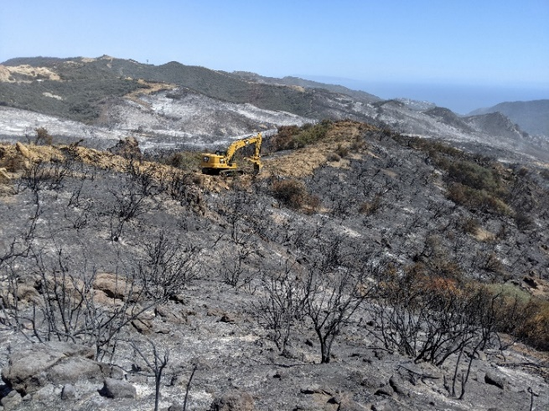

Figure 3: Heavy equipment fire fighters cover a dozer line as State Park READs watch on during the Palisades Fire in 2021.

- AFTER THE FIRE: FIRE RECOVERY

The responding agency is only subject to repairing resources damaged by fire suppression activities, therefore State Parks is responsible for any recovery work associated with impacts from the fire itself.

4.1 POST-FIRE RESOURCE DAMAGE – FIRE RECOVERY
Recovery work occurs post-repair and includes managing fire suppression repair sites as well as managing impacts from the fire itself and is the responsibility of State Parks. State Parks desires to partner with the responding agency, allied agencies, non-profits, and the Fire Safe Council to pursue “Recovery Beyond Repair.” The purpose of “Recovery Beyond Repair” is to return the affected park unit to high quality conditions than it was prior to an incident in preparation for returning fire. Recovery strategies may include, but are not limited to:

Cultural
- Coordinating District Superintendent closure orders for impacted archaeological sites.
- Increased LE patrols and lookouts for looting.
- Securing impacted sites and buildings from further erosion and impacts during the rainy season by installing straw waddles, sandbags, tarps, etc.
- Resource monitoring of impacted cultural sites for vandalism and impacts from post-fire storms.
- Post-fire cultural resource surveys to document previously unrecorded sites, or update records and boundaries for known sites.
- For historic restoration, repairs need to be done with like materials. Where buildings are built and repaired with wood or other fire prone materials, incorporating fire-hardening measures, such as sprinklers, should be included in restoration plans.
Natural
- Scatter dead material, up to 30%. To prevent the spread of invasives, dead material should come from ‘clean’ areas.
- Planting/Reforestation.
- Keying In to hold brush in place.
- Monitoring fire effects.
- Emergency hazard tree inspection.
- Eliminate volunteer trails.
- Prioritize prescribed fires adjacent to the incident. Facilitating prescribed burns contiguous to the wildfire incident boundary is a strategy to reduce fuel and reintroduce fire. The prescribed fires would be anchored from the previously burned landscape, lessening the risk of spotting or escape.
- Conducting Early Detection, Rapid Response (EDRR) weed monitoring and treatments in sites impacted by heavy equipment, campsites, helipad locations.
- Restoring damaged sensitive natural resources impacted by the fire and/or suppression activities.
- Erosion control and prevention on burned slopes. Adding slash, hay, or mulch to exposed slopes to help prevent erosion. Steelhead in Topanga Creek are especially at risk of debris and sediment flow and temporary structures may need to be put in place to reduce large amounts of sediment flowing at a time.

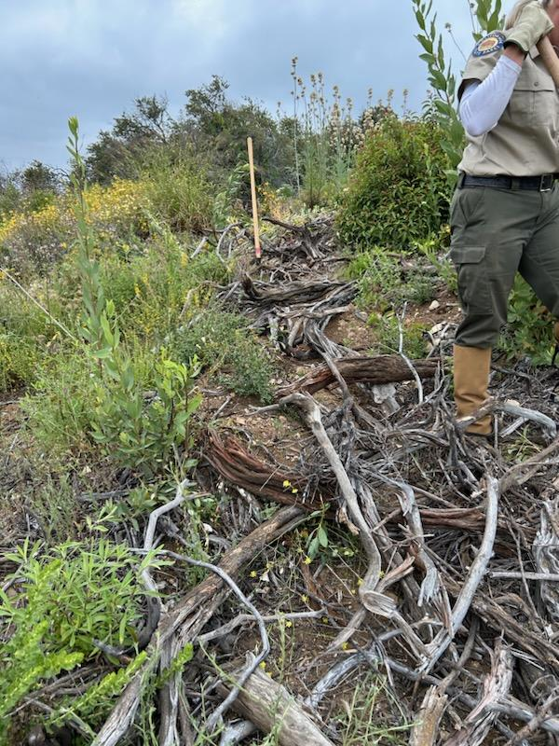
Figure 4: Covering illegal bike trails created on old dozer lines. This is a constant issue in Topanga State Park. Photo: Carlos Calderon

Facilities
- Installing warning signs.
- Installing interpretive signs.
- Installing temporary closures.
- Repair and replacement of burned fences, bridges, and buildings.
- Temporary barriers for trails.
- Any additional work required for the recovery and re-opening of roads and trails.
- For historic building restoration, repairs need to be done with like materials. Where buildings are built and repaired with wood or other fire prone materials, incorporating fire-hardening measures, such as sprinklers, should be included in restoration plans.

4.2. TREE HAZARDS
All tree hazard determinations will be approved by a State Parks Certified Tree Hazard
Inspector or a State Parks Forester. Tree hazard assessment in developed areas will follow the Department’s Tree Safety Program Guidelines and Standards. Assessments along roads shall follow the State Parks Vegetation Management Guidelines for Roads and Trails.

4.3 FEDERAL EMERGENCY MANAGEMENT AGENCY (FEMA)
If an incident is declared to be a Major Disaster, State Parks may be eligible for FEMA Public Assistance. State Parks may also be eligible for filing Fire Management Assistance Grants to assist districts in the mitigation, management, and control of fires on State Parks property, which threaten such destruction as would constitute a major disaster. The State received multiple Major Disaster Declarations for its wildfires in 2020.

4.4 WATERSHED EMERGENCY RESPONSE TEAM (WERT)
WERT, run by CAL FIRE and the California Geological Survey, aims to help communities prepare after wildfire by rapidly documenting and communicating post-fire risks to life and property posed by debris flow, flood, and rock fall hazards. WERT identifies and characterizes values-at-risk, which are resources at risk of damage or loss by post-wildfire geologic and/or hydrologic hazards. State Parks natural and cultural resources can be considered values-at-risk and be subject to WERT assistance.

A qualified State Parks READ/F or other Technical Specialist shall be assigned to assist WERT teams operating on State Park property.

4.5 BURNED AREA EMERGENCY RESPONSE (BAER)
The Burned Area Emergency Response (BAER) program is designed to address these emergency situations through its key goals of protecting life, property, and critical natural and cultural resources. The objective of the BAER program is to determine the need for and to prescribe and implement emergency treatments on Federal Lands to minimize threats to life or property resulting from the effects of a fire or to stabilize and prevent unacceptable degradation to natural and cultural resources.

A qualified State Parks READ/F or other Technical Specialist shall be assigned to assist BAER teams operating on State Park property.

4.7 After Action Reviews
State Park staff who responded to an incident should facilitate an After Action Review (AAR) to discuss what happened, what went well, and what could be improved upon during future incidents. For further guidance on After Action Reviews, please see the Incident Response Pocket Guide (IRPG).

- APPENDICIES

A. National Fire Danger Rating System
The National Fire Danger Rating System (Deeming et. Al. 1978) monitors and archives fuel conditions as they are influenced by weather. NFDRS has five severity levels: Low, Medium, High, Very High and Extreme. Using this system’s fire severity index, some park units have established criteria for visitor activities restrictions and park closure. (See example table below).

Fire Prevention Public Education Notice.

Fire Danger - How Will It Affect You?
Fire Danger Rating | Wood fire permitted in stoves & BBQ pits in designated picnic & campsites | Use of compressed logs | Use of Charcoal | Use of Self-contained stoves | Cigarette Smoking | Park Open
Low | YES | YES | YES | YES | YES | YES
Medium | NO | YES | YES | YES | YES | YES
High | NO | NO | NO | YES | NO* | YES
Very High/Extreme | NO | NO | NO | NO | NO* | NO**

- Fires shall at all times be maintained in a safe condition that does not threaten any person, natural or structural feature.
- Never leave a fire unattended.
- Extinguish all fires prior to departure.
- The prohibition of cigarette smoking under high fire danger includes smoking within a vehicle.
- Park closure applies to all public use vehicles, hikers, bicyclists (mountain and road), and horseback riders.
- Ground fires are not permitted.
- Firewood gathering is prohibited.
- The possession or discharge of fireworks is prohibited.
- Report all wildfires immediately.
- Notify State Parks staff of observed violations.
- Ask a park ranger for further information.

B. Red Flag Program
The National Weather Service Fire Weather Red Flag Program is designed to inform the public of changes in weather that will dramatically increase the fire danger. (http://gacc.nifc.gov/oscc/predictive/weather/AOP.pdf)

- WATCH (Fire Weather Watch) is the headline used by NWS Fire Weather Forecaster when severe fire danger/weather is predicted to occur from 12 to 48 (sometimes 72) hours in the future. The presence of thunderstorms that have the potential to produce dry lightning may reduce the lead-time to less than 12 hours, because this phenomenon is hard to predict.
- WARNING (Red Flag Warning) is the headline used by NWS Fire Weather Forecaster when severe fire danger/weather is predicted to occur within the next 12 hours in the future. A Red Flag Warning is issued when there is high confidence that Red Flag criteria will be met within the next 48 hours or less or criteria are already being met. Longer lead times are allowed when confidence is very high or the fire danger situation is critical. The Warning may be issued for all or selected portions of a fire weather or zones.
- CANCELLATION is the headline used to void an existing “WATCH” or “WARNING” headline.

A bullet format text message (RFW) is used for issuing, updating, and cancelling all Fire Weather Watches and Red Flag Warnings. Complete information regarding the format, content and examples of Fire Weather Watches and Red Flag Warnings can be found here: http://www.nws.noaa.gov/directives/sym/pd01004001curr.pdf

C. Glossary
Background: Terms defined in the Glossary are for State Parks staff to reference. Most definitions are sourced from the National Wildfire Coordinating Group.

AERIAL FUELS: Living and dead plant materials that are upright or suspended which are physically separated from the ground by more than 4 feet and separated from each other such that air can circulate around the fuel particles. Includes tree trunks, branches, leaves, moss, bark, snags, etc.
ANDROID: A parcel of land owned and managed by State Parks that is part of a larger park but is not connected with it.
BLACK LINE: A fire set along the inside edge of the control line to consume unburned fuel between the line and the fire edge.
BACKFIRING:
CONTAINED FIRE: A fire which has a containment line completely around its perimeter and around any spot fire, and which has a good chance of being held within the containment line through the next burning period.
CONTROL LINE: An inclusive term for all constructed or natural fire barriers and treated fire edge used to control a fire.
DUFF: The partially decomposed organic material of the forest floor that lies beneath the litter.
DOZER LINE: Fireline constructed by the front blade of a dozer.
EXTENDED ATTACK: is the phase of the incident when Initial attack capabilities have been exceeded.
FIRE BREAK: Natural or constructed barrier used to stop or check fires, or to provide a control line from which to work. Sometimes called a fire lane. A Firebreak differs from fuel break in that fuel has been removed rather than modified.
FIRE CAMP: A camp used to accommodate firefighters and equipment while suppressing a fire. Also called base camp, side camp, or fly camp, depending on location and function.
FIRE LINE: The part of a control line that is scraped or dug to mineral soil. Sometimes called a fire trail or handline if completed by a crew with no mechanical assistance.
FIRE SUPPRESSION: All the work of extinguishing a fire following its detection, including reconnaissance; hot-spotting and first attack; line location and construction; control, mopup and patrol; and declaring the fire contained and controlled.
FIRE USE: The management of naturally ignited wildland fires to accomplish specific resource objectives within a pre-defined area.
FUEL BREAK: A wide strip or block of land on which the native vegetation has been modified so that fires burning into it can be more readily extinguished. It may or may not have control lines constructed in it prior to fire occurrence.
GROUND COVER: All living woody and herbaceous plant material within two feet of the ground surface.
GROUND FUELS: Dead combustible plant and animal organic matter such as grass, shrubs, leaves, twigs, branches, bark, duff, logs, and the like, lying on the ground or vertically oriented up to four feet in height.
HAND LINE: Fireline constructed by work crew using hand tools.
INITIAL ATTACK: The fire suppression action taken by people and equipment that are first to arrive at an incident. The kind and number of people and equipment responding to initial attack varies depending upon the fire danger, fuel type, values to be protected, and other factors. Initial attack usually involves a small number of people and equipment, and incident size is small.
LITTER: The top layer of the forest floor, composed of loose debris of dead sticks, branches, twigs, and recently fallen leaves or needles, little altered in structure by decomposition.
MANAGED BURN: Wildfires that strategically burn out with contained boarders and appropriate oversite.
MASTICATION LINE: Fireline constructed by a machine mounted on an excavator type tractor, which moves through the forest to grind or chip trees and brush, with medium impact to soil.
MOW LINE: Fireline constructed by a machine utilizing one or more revolving blades to cut grass with minimal impact to soil.
OPERATIONAL PERIOD: The period of time scheduled for execution of a given set of tactical actions as specified in the Incident Action Plan. Operational periods may be 12 or 24 hours depending on the fire response agency.
SHADED FUEL BREAK: A shaded fuel break is designed to reduce, modify, and manage fuels within a designated area that does not remove all the vegetation in that area. A shaded fuel break can require machinery, but not always. It maintains a tree canopy while reducing the fuel below, limiting a fires ability to move upward and forward.
WET LINE: A fuel break designed to stop the spread of fire by removing the heat from the fire. A wetline does not reduce vegetation.

D. Federal and State Endangered/Sensitive Species Acronyms

E. CAL FIRE/State Parks Interagency Agreement
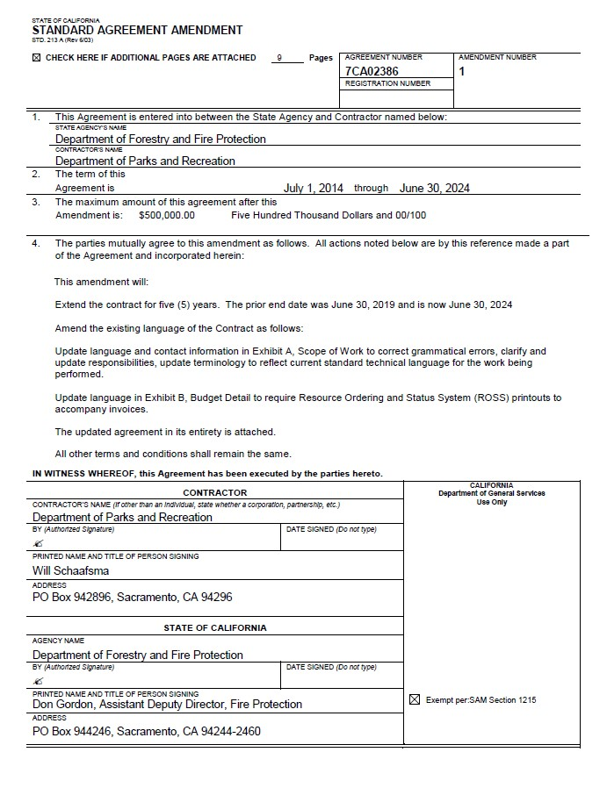
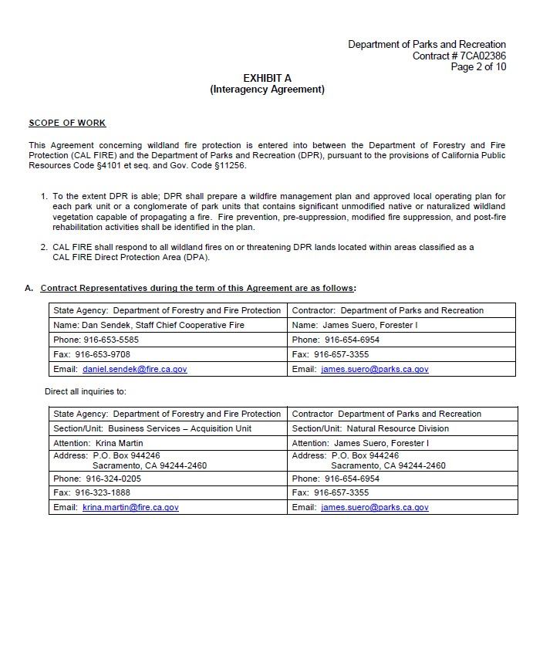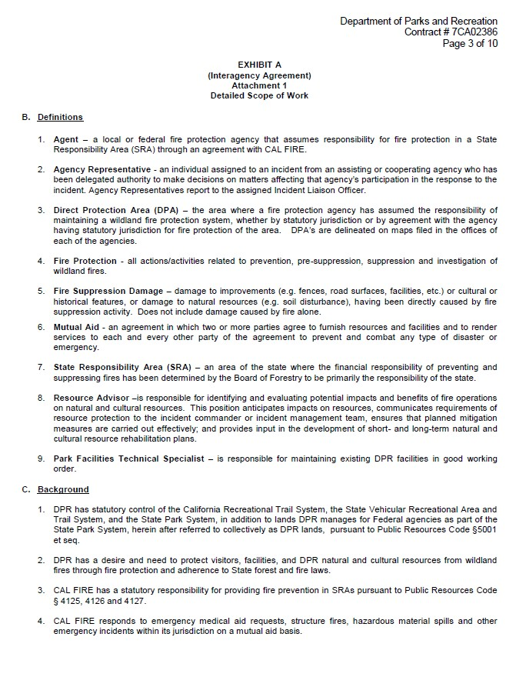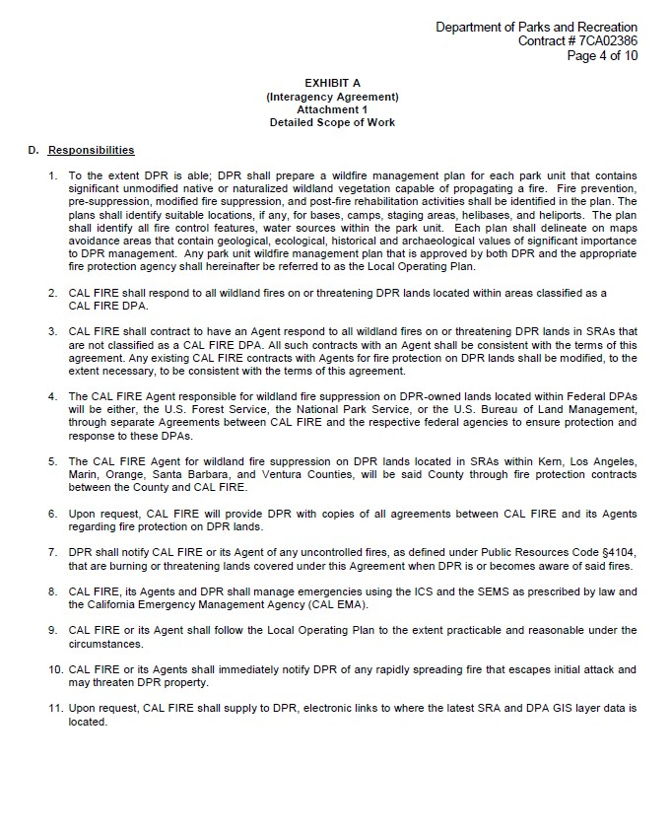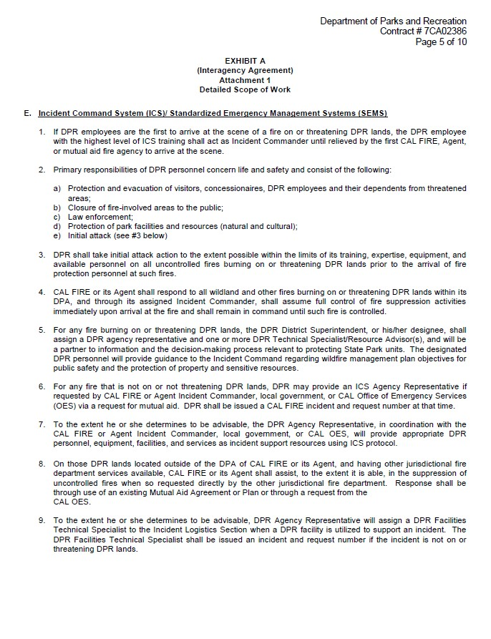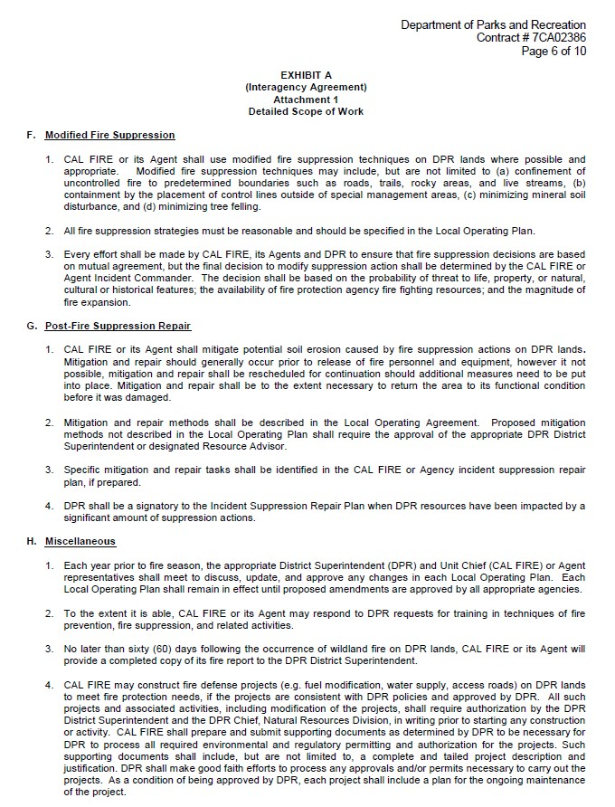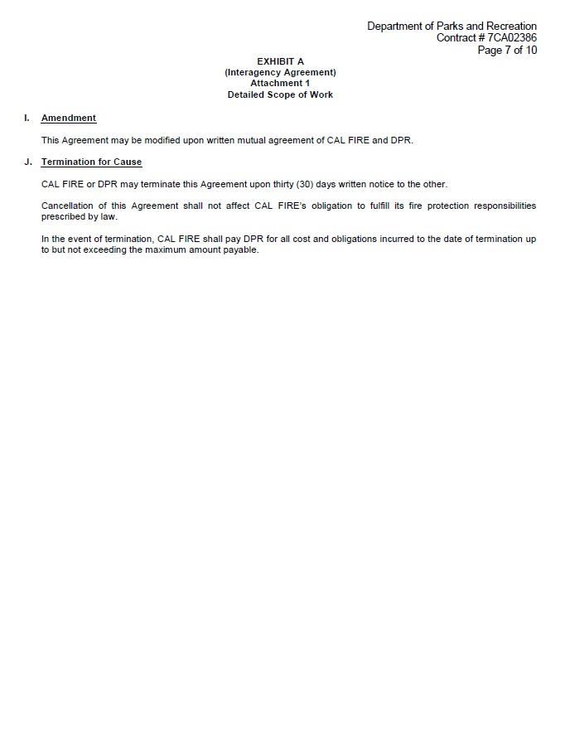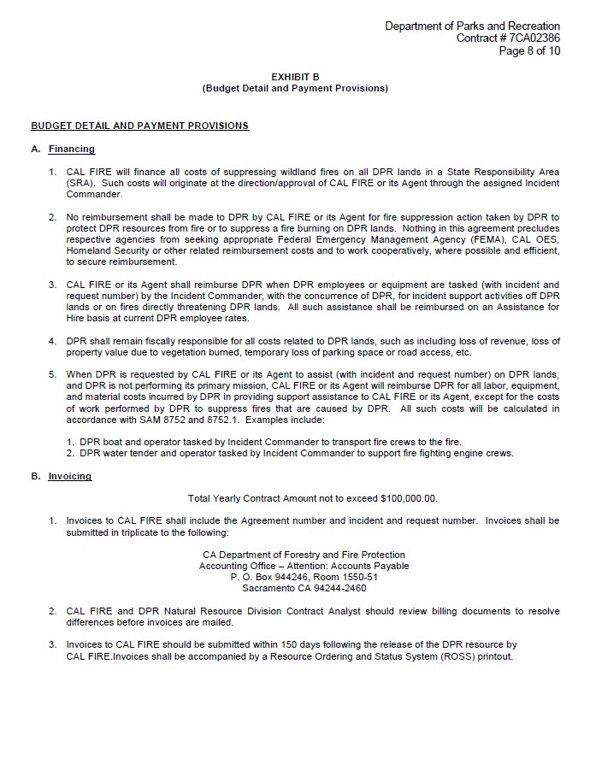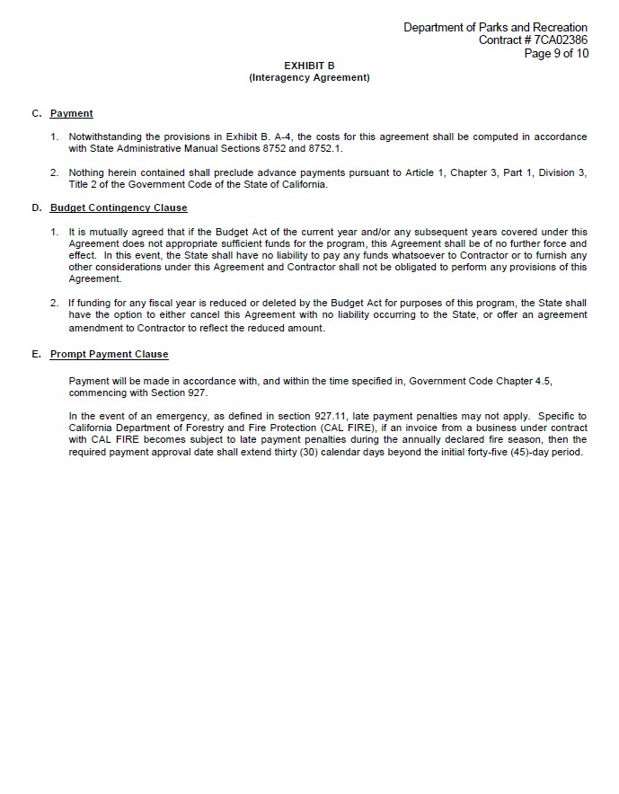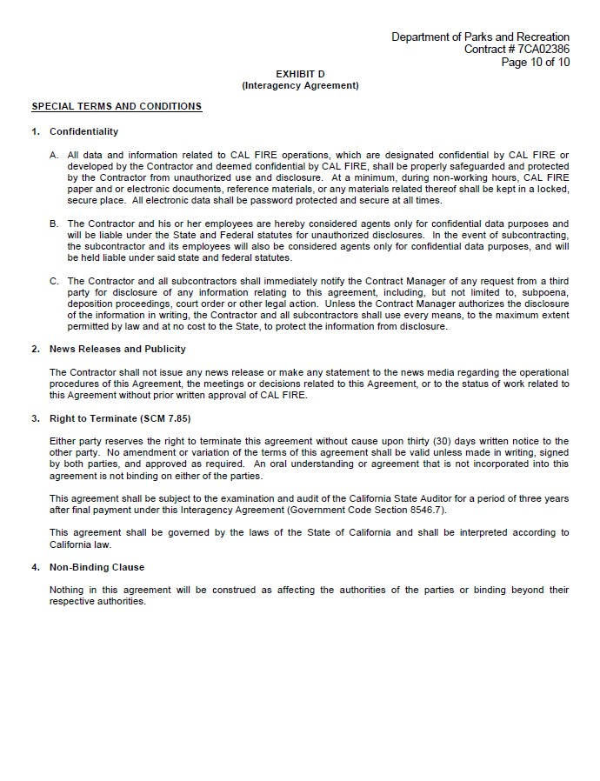

F. Out-of-District Request Protocol

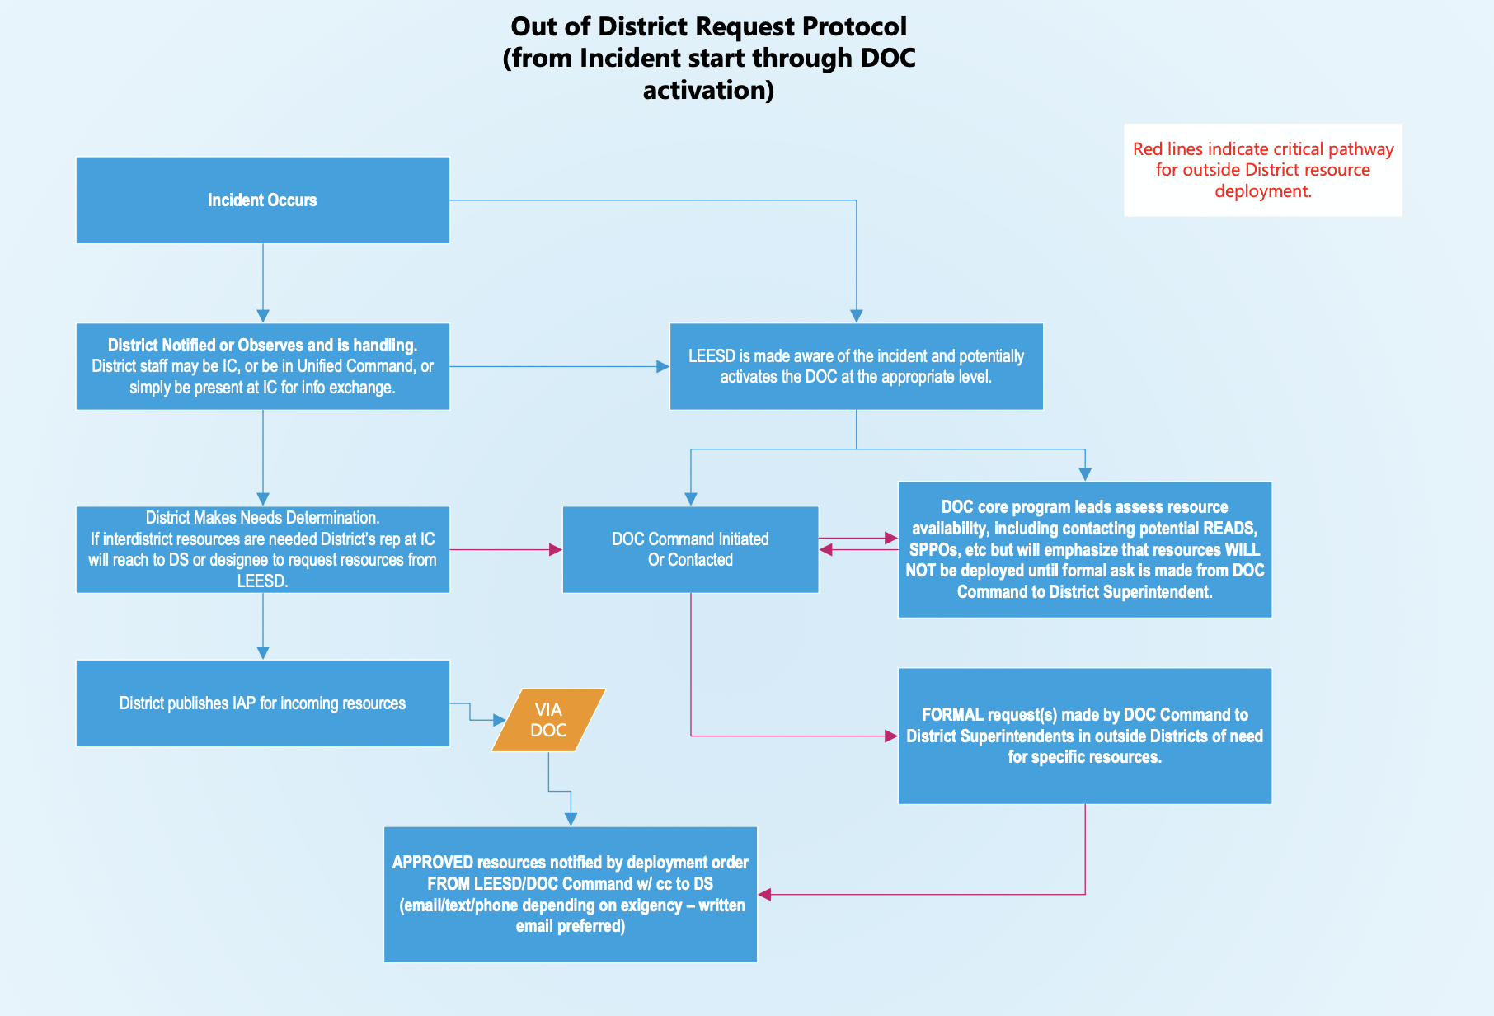

G. References

- Brown, A.A., and K.P. Davis. 1973. Forest Fire Control and Use. McGrawHill- Book Company. New York, NY. 686 pp.

- California Division of Forestry. 1966. Principles of Fire Management. Sacramento, California.

- California Department of Forestry. 1978. California Forestry Handbook Sacramento, California.

- California Department of Parks and Recreation. 1976. Wildland Fuel Management Guidelines for the California State Park System. Sacramento, California. 47 pp.

- California Department of Parks and Recreation. 1993. Tree Safety Program. Policy, Administration, and Standards. Park Services Division, Sacramento, CA. 48 pp.

- California Department of Parks and Recreation. 1978. Resource Management Directives for the California State Park System. Sacramento, California. 263 pp.

- California Department of Parks and Recreation. 1998. Radio System Users Handbook. Sacramento, California. 24 pp.

- California Department of Parks and Recreation & California Departments of Forestry and Fire Protection. 2004. Interagency agreement for wildland fire protection. Agreement # State Parks C04K0007, CDF 7CA33804. July 1, 2004 – June 30, 2009.

- California Office of Emergency Services. 1989. Field Operations Guide. Incident Command System Publication ICS 420-1. Sacramento California.

- Cheatham, N.H. and J.R. Haller. 1975. Annotated List of California Habitat Types. Univ. Calif. Natural Land & Water Reserves System.

- Clampitt Fire: View From Valencia 9-25-1970. Available at: https://scvhistory.com/gif/galleries/fire092570/ (Accessed: 27 September 2024)

- Cohen, J.D. 2000. Preventing Disaster – Home Ignitability in the Wildland-Urban Interface. J. Forestry. 98(3) p.15-21

- Cohen, Jack. 2008. The wildland-urban interface fire problem: A consequence of the fire exclusion paradigm. Forest History Today. Fall: 20-26., pp.20-26.

- Crimmins M.A. and A.C. Comrie. 2004. Interactions between antecedent climate and wildfire variability across south-eastern Arizona. International Journal of Wildland Fire 13. 455-466 pp.

- Deeming, J.E., R.E. Burgan, and J.D. Cohen. 1978. The National Fire Danger Rating System. USDA Forest Service, Gen. Tech. Rep. INT-39. 63 pp.

- Fischer, W.C. and C.E. Hardy. 1976. FireWeather- Observers Handbook. USDA Forest Service Agricultural Handbook 494 pp.

- International Fire Code Institute. 2000. Urban–Wildland Interface Code. Whittier, CA. 49 pp.

- Keeley, J.E. and P.H. Zedler. 2009. Large, high‐intensity fire events in southern California shrublands: debunking the fine‐grain age patch model. Ecological Applications. 19(1). 69-94 pp.

- Keeley, J.E. and A.D. Syphard. 2017. Different historical fire–climate patterns in California. International Journal of Wildland Fire, 26(4), 253-268 pp.

- Keeley, J.E. and A.D. Syphard. 2019. Twenty-first century California, USA, wildfires: fuel-dominated vs. wind-dominated fires. Fire Ecology, 15(1), 1-15 pp.

- Kramer, H.A., M.H. Mockrin, P.M. Alexandre, S.I. Stewart, V.C. and Radeloff. 2018. Where wildfires destroy buildings in the US relative to the wildland–urban interface and national fire outreach programs. International journal of wildland fire. 27(5). 329-341 pp.

- Los Angeles Fire Department Historical Archive. The Santa Monica Mountain Fire, November 23 to 30, 1938. Available at: https://www.lafire.com/famous_fires/1938-1123_1938BrushFire/112338_BrushFire.htm (Accessed: 27 September 2024).

- Los Angeles Fire Department Historical Archive. Official Report Old Topanga Incident. Available at: https://www.lafire.com/famous_fires/1993-1102_OldTopangaFire/1993-1102_OfficialReport_OldTopangaIncident.htm (Accessed 27 September 2024).

- Nichols, D., R. Loggins, R.C. Fraitag. 1998. Powerline Fire Prevention Field Guide. California Department of Forestry and Fire Protection. Sacramento California. 111 pp.

- Radeloff, Volker C.; Helmers, David P.; Kramer, H. Anu; Mockrin, Miranda H.; Alexandre, Patricia M.; Bar Massada, Avi; Butsic, Van; Hawbaker, Todd J.; Martinuzzi, Sebastian; Syphard, Alexandra D.; Stewart, Susan I. 2017. The 1990-2010 wildland-urban interface of the conterminous United States - geospatial data. 2nd Edition. Fort Collins, CO: Forest Service Research Data Archive. https://doi.org/10.2737/RDS-2015-0012-2.

- Syphard, A.D., T.J. Brennan, and J.E. Keeley. 2018. Chaparral landscape conversion in southern California. Valuing chaparral: Ecological, socio-economic, and management perspectives, pp.323-346.

- Syphard, A.D., T.J. Brennan, and J.E. Keeley. 2019. Extent and drivers of vegetation type conversion in Southern California chaparral. Ecosphere, 10(7), p.e02796.

- Western Forestry and Conservation Association. The Western Fire Fighter's Manual.

- United States Departments of Interior and Agriculture. 2005. Wildland Fire Use – Implementation Procedures Reference Guide. 71p.

- United States Forest Service. Fire Control Handbook. Region 5. San Francisco, California.

Keeley&Syphard_2018_Historical patterns of wildfire ignition sources in CA

H. DPR Fire Reporting Forms

[PLACE HOLDER - Forms 385, 385A, and 386]

- Attachements - Maps

Map 1: [NAME of Map – i.e., Avoidance areas]

Map 2: [NAME of Map – i.e., Entire Park Extent]

